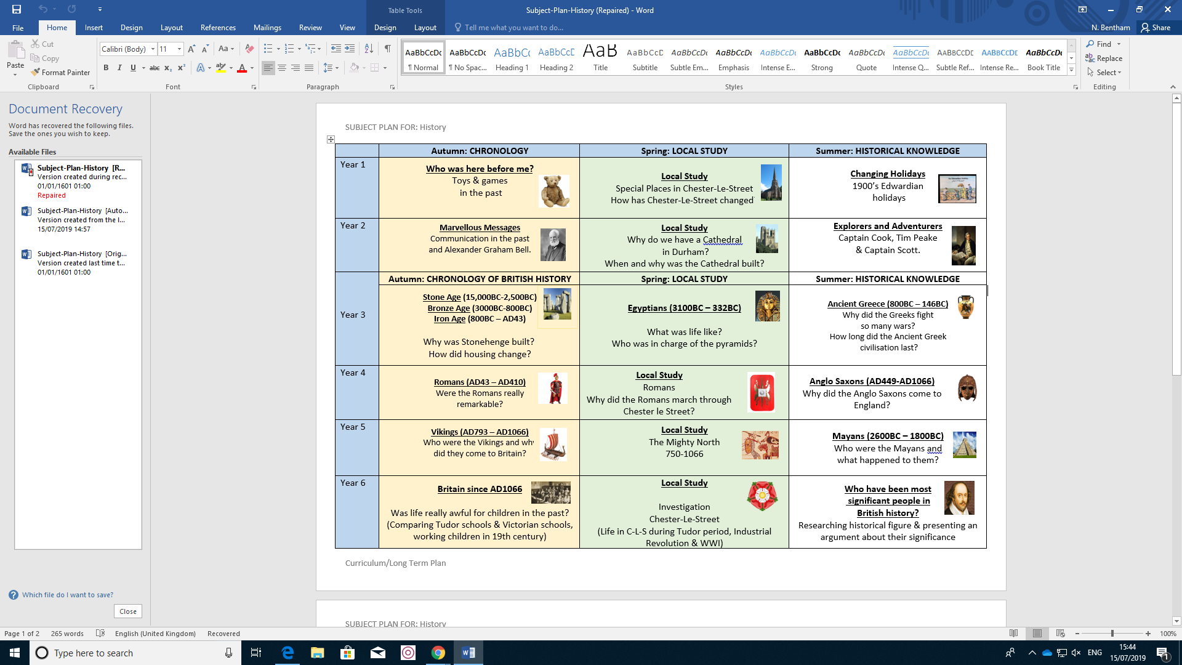

**Developing our Children as Historians**: Pupils will extend their chronological knowledge and consider key features from different periods of time. They will make connections and consider similarity and differences using some primary sources. There will be a focus on the development of pupil use and understanding of historical interpretations.

Historical communication: Development of timeline skills, use of key historical terms, key feature descriptions, reading and inference, speaking and listening, producing annotated diagrams, comparing interpretations.