CESTRIA PRIMARY SCHOOL

Policy and Guidelines for Behaviour Management

Behaviour Management Policy and Guidelines

We aim for Cestria to be a place of excellence where children can achieve their best in their academic, creative, personal and physical development. We are a caring school where children and adults feel they can contribute and are valued as individuals. We strive to create and maintain close partnership between children, parents and staff to develop children into lifelong learners and responsible citizens.

We believe that a child cannot learn effectively unless he or she feels secure, successful and happy. We are committed to helping children to develop socially acceptable attitudes, self-discipline and self-confidence, as well as an acceptance of responsibility for their own actions.

Cestria Primary School rewards good behaviour, as we believe that this will develop an ethos of kindness and cooperation.

The purpose of our behaviour policy is:
• To help us maintain a consistent approach which supports the aims and values of the school
• To create a positive and orderly atmosphere which supports teaching and learning
• To create a safe, secure environment for children and staff through the clarification of expectations, roles, rights and responsibilities
• To ensure consistent implementation of this policy from all staff especially in the delivery of rewards and sanctions
• To ensure that staff, pupils, parents, governors and visitors to the school have a shared understanding of our practice and procedures with regards to managing behaviour

At Cestria Primary School we:
- Use positive praise as a form of acknowledging good behaviour and correcting unwanted behaviours
- Take a personal interest in the progress and welfare of every child
- Expect all staff to take responsibility for promoting good behaviour at all times
- Expect all staff and visitors to the school to act as positive role models
- Seek to show children that if poor behaviour occurs, it is the behaviour we dislike not the child
- Always take unacceptable behaviour seriously
- Believe that it is crucial to work closely with parents on managing behaviour issues when necessary and especially where there are persistent or serious difficulties
- Seek to identify and address any persistent difficulties
- Ensure that all necessary staff are informed of any issues/needs that may arise in order to ensure consistency of approach
- Greet children warmly regardless of any undesirable events on the previous day challenge negative comments from other children regarding a child’s personality, ability, appearance or cultural background
- Ensure that vulnerable children – such as those with special educational needs, physical or mental health needs - receive sensitive and well-matched behavioural support

Roles and Responsibilities
At Cestria Primary School, we believe that all staff and parents share responsibility for managing and promoting good behaviour. In this way, children realise that the way they behave is of importance to everyone.

- Class teachers endeavour to ensure that their children behave well at all times
- Teachers contribute to the open door policy for parents and deal with their concerns in a timely, respectful, sympathetic and professional manner, involving senior staff as appropriate
- Staff keep a record of significant incidents/log of behaviours for identified children which is monitored and reviewed by the Leadership Team
- Teaching Assistants, Special Needs Assistants and Lunch Supervisors support the teaching staff in the above
- The Senior Leadership Team will be responsible for ensuring that this policy is implemented and for reporting to the governing body on its impact
- Parents have a vital role in promoting good behaviour in school and so effective home/school liaison is very important. It is important that teachers can gain the full support of parents when dealing with any child’s behaviour
- We expect parents to behave in a reasonable and civil manner towards all school staff. Incidents of verbal or physical aggression to staff by parents of children in the school will be reported to the Headteacher, who will take appropriate action
- We expect parents to support the actions of the school when consequences are imposed. If they have any concerns about the way their child has been treated, they should initially contact the class teacher
- The Governing Body has the responsibility of setting down general guidelines on standards of behaviour and of reviewing the effectiveness of the policy
- The Governors support the Senior Leadership Team in carrying out the policy

Supporting Children with Additional Needs
Any child, at any time during their schooling, could experience a period of turbulence which may result in unwanted behaviours. For a small number of children, they may have a specific underlying condition/need which should be taken into account. Approaches used to support these children could include:
- Discussion with the child about their behaviours
- Continued involvement from and liaison with parents
- Close liaison with the Special Educational Needs Co-ordinator (SENCo)/Deputy/Headteacher)
- Work suitably differentiated to match the child’s needs
- Providing additional support in liaison with the SENCo
- Involving external agencies
- Implementation of a behaviour plan
- Investigating options for alternative provision (dependent upon criteria, availability etc.)

We are working towards being a Rights Respecting school:
Every class has a charter or rules/routines that they will follow to ensure they feel safe, secure and valued within a classroom. All members of staff in that class alongside the children have agreed to these terms. This also links to ‘Jigsaw’ where we cover Personal, Social and Health Education on a half termly basis.
Team Teach
The safety of the children at Cestria Primary is vital. We have members of staff who are Team Teach trained this allows them to safely remove/restrain children who are a risk to themselves and others. This is a rare occurrence and the process is 95% talk and only 5% physical.

Any approaches used will be reviewed regularly and adapted as necessary
Bullying
Bullying is a particular behaviour by which one person has power over another. Incidences of bullying will be dealt with very seriously and in accordance with the school’s Anti-Bullying Policy.

Attendance
Punctuality and good attendance, particularly the prevention of unauthorised attendance, is an integral part of our school policy on behaviour. Encouragement to attend school regularly emphasises positively the importance of school.
Parents will be reminded of their responsibilities for attendance and punctuality when necessary.
Racial Harassment
All incidents relating to Racial Harassment will be taken seriously. It will be made clear to children that such practices are unacceptable and will not be tolerated.

In the Playground
At lunchtimes and playtimes, our staff’s main purpose is to keep our children safe and happy. During lunchtimes dojo’s are used as a positive reward. If there is any negative behaviour lunchtime staff follow their policy and if it needs a member of teaching staff KS1/KS2 Behaviour Lead will deal with it. All members of lunchtime staff have books which they record any incidents and KS1/KS2 Behaviour Leads monitor the behaviour who then pass on information to Senior Management.
Exclusion
In most cases fixed or permanent exclusion will be the last resort after a range of measures have been tried to improve the pupil’s behaviour. A decision to exclude a child for a fixed period may be taken in response to breaches of the school’s behaviour policy, including persistent disruptive behaviour. If this occurs parents may be asked to remove their child for a specific, short term period while intervention strategies are put in place to help the child improve. Exclusions whether fixed term or permanent can only be imposed by the Headteacher or in his/her absence a designated representative, normally the Deputy Headteacher. Where exclusion is used the school conforms to the County Council Guidance. If a child is excluded for a period of less than 5 days the school will provide work – it is the parent’s responsibility to ensure the child completes the work and returns it to the school for marking (parents can be fined if their child is found in a public place during an exclusion). From Day 6 of an exclusion, temporary alternative arrangements for schooling, will be made for the child. In the event of a permanent exclusion the LA will contact parents with details of the Day 6 provision.

Behaviour Beyond the School Gate
Children are expected to uphold the reputation of the school whenever they are out of school whether they are taking part in an official school trip/outing or wearing their uniform to and from school. Children may be subject to disciplinary sanctions if their behaviour brings the school into disrepute or has repercussions for the orderly running of the school.

Allegations
Any allegation of misconduct against a member of staff will be taken seriously and referred to the Local Education Officer and dealt with using the County procedure.
Communicating the Behaviour Policy
The Behaviour Policy is circulated to parents (via website) and staff and discussed with the children at least annually.

Staff training
The school has a comprehensive behaviour management training programme that meets the needs of all staff including intensive support for those experiencing difficulties. All new staff are expected to read the Behaviour Management Policy as part of their induction.

Monitoring and Review
The success of the school’s Behaviour Management Policy and provision is evaluated through school self-evaluation and reporting activities such as:
- Monitoring of classroom practice by the Leadership Team (including the Headteacher)
- Analysis of tracking data for individual children and for cohorts (class and individual logs)
- Incidents involving children with SEN will be recorded separately and passed on to the SENCO.

Who was consulted?
Governors, staff, children and parents were consulted during the development of this policy.

Policy reviewed- Spring 2020
Linked policies/procedures:
Anti-Bullying
Child Protection and Safeguarding
Allegations of Abuse against Teachers
and Other Staff
Complaints Procedure (responding to
Parents concerns)
Your Behaviour, Your Choice

- Examples of Good Behaviour:
- Listen carefully to instructions
- Try your best with your work
- Treat adults and children with respect
- Show good manners
- Treat others kindly with actions and words
- Look after your friends
- Always tell the truth
- Play fairly and share with others
- Think about the feelings of others
- Playing fairly and demonstrating respect when playing at break/ lunch times.

- Rewards:
- Verbal praise
- Class Dojo Points
- Class Dojo linked with parents
- Stickers
- Lunchtime rewards (stickers and dojo’s)
- Stickers and certificates
- Note from teacher through dojo
- Sent to Head Teacher (Head teacher awards)

Classroom Behaviour steps
Step 1- Teacher warnings
- Your teacher will have a quiet word away from others
- A verbal warning (teachers must make it clear that the child has been given a warning, the reason why and how they can correct their behaviour- this needs to be recorded on your class behaviour log, see appendix 1)
Step 2 – Time out
If you continue to behave inappropriately you will…
- Have some ‘time out’ during break time (KS1 5 minutes, KS2 10 minutes)
(teachers will decide where ‘time out’ will take place- taking into consideration the individual, make it clear to the children why they are on time out and how their behaviour can be corrected - this needs to be recorded on your class behaviour log, see appendix 1)
Step 3 – Sent to another member of staff
If you continue to misbehave following all of the above you will be…
- Sent to another teacher (within the year group)
- Sent to (KS1 Behaviour Lead) or (KS2 Behaviour Lead)
If you send a child to another teacher it is your responsibility to take them and collect them after 10 minutes.
- This needs to be recorded on your class behaviour log, see appendix 1
Step 4- Serious
If your behaviour is more serious…
- You will be sent to Senior Leadership Team and your playtime will be removed or an appropriate sanction will decided upon
- Parents will be contacted
- External agencies may be contacted
Please note:

- Parents might be contacted by their child’s class teacher at any stage (if it is repeated behaviour or to prevent poor behaviour escalating).

- Staff will inform and work with parents of children with ongoing issues & support wherever necessary.

Rewards
Dojo points will be used to reward positive behaviour at the teacher’s discretion. Points will be reset at the end of every half term and the child with the highest points will be recognised in an assembly. When children achieve 50 dojo’s they will be recognised in assembly (teachers can still reward children with other incentives e.g. stickers).

Lunchtime behaviour steps

Step 1- Warning
- Speak to child and explain what it is that they are doing wrong- make sure they understand that they have a warning and how they can correct their behaviour.

Step 2- Time out
- Have some ‘time out’ during lunch time (KS1 5 minutes, KS2 10 minutes)
(Lunch staff will decide where ‘time out’ will take place- taking into consideration the individual, make it clear to the children why they are on time out and how their behaviour can be corrected).
- This needs to be recorded in the lunchtime behaviour log- if you feel this needs to be passed on to the teacher see them after lunch.

Step 3- Sent to teaching staff
- Sent to (KS1 Behaviour Lead) or (KS2 Behaviour Lead) for the remainder of lunch time.
- This needs to be recorded in the lunchtime behaviour log- if you feel this needs to be passed on to the teacher see them after lunch.

Step 4- Serious
- You will be sent to Senior Leadership Team and your playtime will be removed
- Parents will be contacted
- External agencies may be contacted

Rewards
During lunch children will be rewarded with dojo’s (maximum of 5) and stickers (please try and keep a note to make this fair).
Policy Reviewed Annually

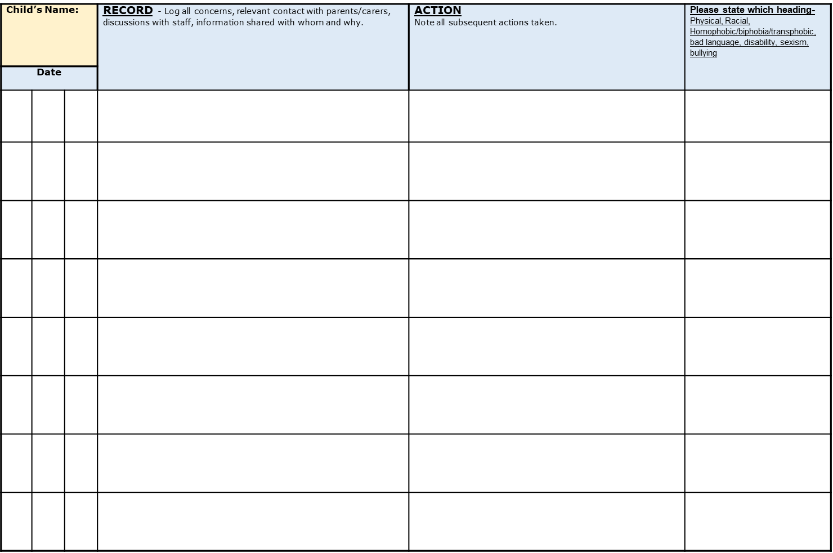
Appendix 1

