CESTRIA PRIMARY SCHOOL

Maths Policy and Guidelines

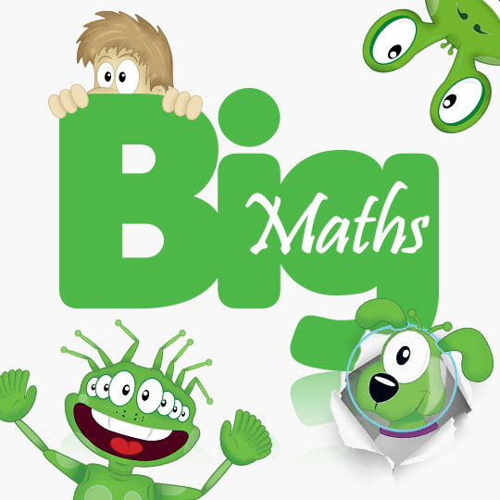

MATHS at Cestria

What is Big Maths?
Big Maths is a teaching method that makes progress in Maths simple, fun and with clear progression.
It ensures that children receive a highly positive approach to maths. Each week they take part in tests, which track all skills learnt; children can then see their own journey through maths.

At Cestria we want to ensure we ‘get children properly numerate as they journey through school’, Big Maths provides an accurate and simple, but highly effective, framework that guarantees progress. This framework is known as CLIC (Counting, Learn Its, It’s Nothing New and Calculation) is characterised by accurate steps of progression (known as Progress Drives) that make new learning easy by building on previous skills learnt.

The CLIC resources provide progression at a glance as well as progression in detail. This ensures that all staff members teaching from the programme are following the same approach and therefore making learning clear for children. It also allows staff to fill in any gaps and to prevent future gaps from developing as all children make their way through the system with the necessary pre-requisite skills to meet new learning with further success and confidence.

Big Maths comes with a wealth of resources including jingles to help children learn their ‘Learn Its.’
http://www.andrelleducation.com/product/big-maths-beat-that-challenge-jingles/
Big Maths Characters

At Cestria we have the Big Maths characters displayed in every classroom so that children can directly link their learning across their school life. During each lesson on number, the children will experience CLIC taught in various ways, often using the Big Maths characters below.

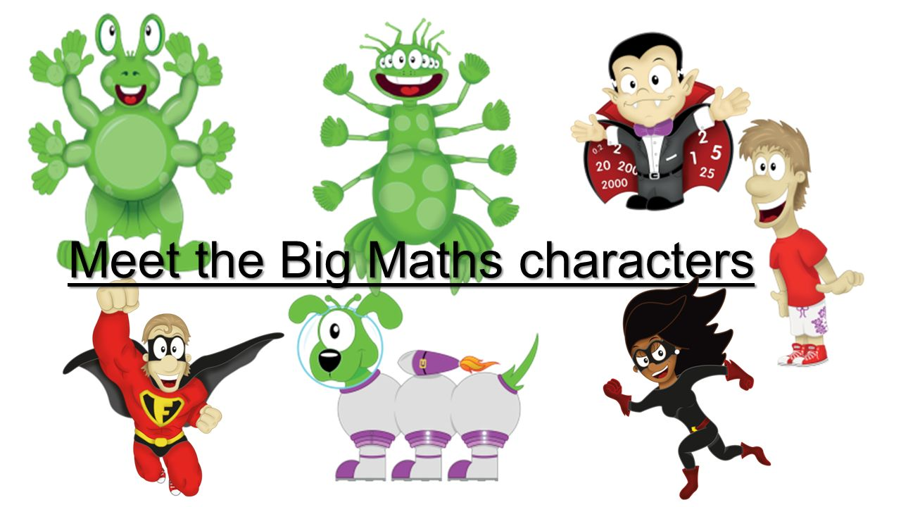

What is CLIC?

Counting – Counting is done in many ways including counting forwards and backwards in various increments; work on place value and reading and ordering numbers.
Learn Its – Learn Its are 72 number facts which are learnt throughout the years from Reception to Year 4. They are split across the different terms so that each class works on a few Learn Its at a time, to ensure they are fully embedded. 36 are addition facts and 36 are multiplication facts; these are learnt in class and practiced at home and are tested once a week in school through the ‘Big Maths Beat That!’ Challenge.
It’s Nothing New – Children use a bank of facts and methods that they already have, to solve problems and that each step of progress is very small; children will use and apply their skills and methods to a range of different situations and problems.
Calculation – This is often the main part of the maths lesson which focuses on teaching solid written and mental methods for addition, subtraction, multiplication and division. The children move through progress drives which introduce small, focused steps of progress throughout the year.

What is SAFE?
Shape
Amounts – time is taught as part of the continuous provision in school. Each class have four clocks displayed and time is referred to continually throughout the day.
Fractions – we have a focus on fractions by having a ‘fraction day’ weekly in KS2 and fortnightly in KS1.
Explaining Data

CLIC/SAFE test
• ‘Big Maths Beat That!’ – timed challenge where children answer ‘Learn Its’ questions. The aim is to beat their previous score.
• CLIC test – 10 questions relating to concepts taught at children’s individual level throughout the daily CLIC lessons.

Using and Applying
When children have shown that they are secure in a topic area, they move onto a range of Using and Applying Questions/Activities to ensure they have mastery of all skills that have been taught.

Each class teacher hands in this data on a half termly basis to the maths coordinator, this is then analysed and mapped in line with national expectations. By doing this we can ensure that we identify any children who are currently off track and therefore put interventions and support in place.
Outer Numeracy
We follow an approach where we build on children ‘Core maths’ first so that they have basic skills needed to be numerate. Then each week children’s maths lessons are linked to real life maths where children use and apply the skills learnt through real life problems.

Planning
Here at Cestria all teachers follow the ‘CLIC on your planning’ document. This covers all aspects of CLIC. For the additional maths strands teachers follow a mapping document provided by the maths coordinator-this is directly in line with the National Curriculum 2014.
http://www.andrelleducation.com/product/big-maths-clic-on-your-planning-england/

Assessment
We complete regular assessments as part of Big Maths weekly tests. As part of our assessment procedure, before beginning a new topic, all children complete a ‘Starting Points Page’ to ensure that they are working on activities in line with their ability.

Calculation
Our calculation policy is directly in line with Big Maths. All teachers use the progress drives from the Big Maths handbook for planning and assessment as well the Big Maths column methods.
For more information, please visit the Big Maths Website: https://app.bigmaths.com/home

Maths coordinator: Mrs Kym Robson and Mrs Carole Devlin
Policy to be reviewed annually.

