CESTRIA PRIMARY SCHOOL

Policy and Guidelines for Physical Education

Cestria Primary School Primary Physical Education Policy and Guidance

Contents

Page 3 Introduction

Page 4 Intent

Page 4 Aims

Page 5 Implementation

Page 5 Curriculum

Page 6 Additional Provision

Page 6 Teaching and Learning

Page 6 Equality, Diversity and Accessibility

Page 7 Differentiation

Page 7 Extra-Curricular School Sport and Physical Activity

Page 7 Equipment and Resources

Page 8 Adults Supporting Learning

Page 8 Staff Development

Page 8 Safety Issues (Safe Teaching, Teaching Safely)

Page 8 -9 Clothing and Personal Effects (clothing, jewellery & personal adornment, sensory aids)

Page 9 Changing Provision

Page 10 Impact

Page 10 Assessment

Page 10 Recording and Reporting

Page 10 Leadership and Management

Page 10 Monitoring and Evaluating

Page 11 – 18 Appendix 1

Cestria Primary School Physical Education Policy and Guidance

Introduction

This policy document outlines guidance in relation to:
- our vision for physical education
- the provision of physical education
- how it is taught and learned
- how it contributes to the physical, cognitive, creative, social and personal development of all pupils
- the care, guidance and support of pupils and the framework through which all school leaders, teachers, and other adults supporting learning, understand and manage their roles and responsibilities in the provision of safe practice

All advice and information contained in this policy and guidance, regarding safe practice, is taken from the Association for Physical Education (afPE) handbook on Safe Practice in Physical Education and School Sport, 2016, and DCC Health and Safety Policy and Guidance.

Intent

Through Physical Education at Cestria Primary School we want all pupils to leave physically literate and with the knowledge, skills and motivation necessary to equip them for a healthy, active lifestyle and lifelong participation in physical activity and sport.

To achieve this, we aim to:

- Develop successful learners, confident individuals and responsible citizens who develop as independent enquirers, creative thinkers, reflective learners, team workers, self-managers and effective participators.
- Provide a broad, balanced and relevant curriculum that satisfies the needs of the current National Curriculum and provide pupils with appropriate challenge with acceptable risk.
- Develop a whole school approach to physical development which takes pupils through progressive stages of learning and challenge, enabling them to fulfil their potential, develop competence and control in the gross and fine motor skills that pupils need to take part in PE and sport.
- Educate pupils about, and involve them in, the process of risk management, so that they understand their responsibility in this, in order for them to participate independently in physical activity and to establish good habits and awareness of safety and personal hygiene.
- Ensure pupils have the opportunity to demonstrate that they know and understand how to apply their competence and make appropriate decisions for themselves by challenging pupils to select and use skills, tactics and compositional ideas.
- Provide pupils with opportunities to use imaginative ways to express and communicate ideas, solve problems and overcome challenges, both as individuals and as part of a team or group.
- Ensure pupils understand that PE and sport are an important part of a healthy, active lifestyle and understand the contribution physical activity has on having a healthy body and mind.
- Develop pupils’ stamina, suppleness, strength and the mental capacity (determination and resilience) to keep going.
- Develop an environment in which pupils have the confidence to get involved in PE and sport and are committed to make it a central part of their lives both in and out of school.
- Provide an extra-curricular programme of activities which extends and enriches curriculum provision and provides opportunity for activities to enable pupils to make sufficient progress to access curriculum sessions with greater success.
- Provide opportunities for competition appropriate to the stage of the individual pupil’s development.
- Ensure that pupils enjoy PE and school sport and establish community links and pathways for pupils to engage in life-long participation.
- Provide links to other areas of the curriculum and wider school life.

Implementation

Curriculum
All pupils are entitled to a progressive and comprehensive physical education programme which embraces current Statutory Orders of the National Curriculum and considers individual interests and needs.

Pupils should have access to all components of current National Curriculum programmes of study, which should include developing fundamental movement and basic skills in a broad range of activities in both KS1 and KS2 so that a realistic attempt is made to achieve the expected levels of performance. An example of a balanced curriculum programme (this is shown through our immersive days), based on the use of core assessment tasks.

Curriculum Overview
Occasionally the topics are changed to fit in with School Sports Partnership competitions and leagues.
Yr | Autumn 1 | Autumn 2 | Spring 1 | Spring 2 | Summer 1 | Summer 2
EYFS | Movement Skills  (ABC)  Bikes Trikes and Scooters  Mounting Dismounting Moving | Jungle Gymnastics  Animal Movements on and off apparatus  Elf Hunt  OAA | Dinosaur Dance  Movements and sequences  Bikes Trikes and Scooters  Stopping and Turning | Fundamental Skills  Easter Bunny  Bikes Trikes and Scooters  Stopping and Turning | Games Best of Balls  Balls Skills  Bikes Trikes and Scooters  Mounting Dismounting Moving | Olympics  Running, throwing and jumping  Bikes Trikes and Scooters  Stopping and Turning
1 | Games Fun at the Fair  Throwing and Catching  Throwing and Catching  Target Practice | Animal Gymnastics  Balance Agility Coordination, Movement and equipment moving  Yoga  Salute to the sun | Dance Through the Seasons  Partner work, creating shapes and sequences | Invasion Games Fun at the Fair  Throwing, catching, running, jumping movements | Games  Attacking and Defending | Athletics Sports Day  Throwing Running and Jumping  Running and Jumping  Sports Day
2 | Swimming  Invasion Games  Attack and Defence | Swimming  Gymnastics Under the Sea  Shapes balances and partner work | Swimming  Dance – Toys  Movement patterns and sequences | Swimming  Gymnastics – balancing and making shapes | Swimming  Invasion Games  Mulitskills | Swimming  Athletics  Colour Match: Speed and accuracy
3 | Gymnastics  6 actions on floor mats (balance) | Invasion Games  Throwing and Catching Dodgeball | Dance Extreme Earth  Dance Phrases | Gymnastics Movement  Games  Tennis | Striking and Fielding  Bats and racquets. Throwing and catching | Athletics  Furthest fire: distance when jumping
4 | Gymnastics  Movement and sequences | Games  On the attack: outwitting opponents | Dance  Street Dance | Gymnastics  Apparatus work  OAA -Robinwood | Athletics  Pass the baton: speed and accuracy | Athletics  Running, throwing, jumping
5 | Gymnastics  Acrobatic gymnastics | Rugby/ Netball  Rules and game play  OAA - Scouted | Dance  Indian Delight  OAA - Scouted | Rounders/ cricket  Coordination skills/ teamwork  OAA - Scouted | Athletics  Take aim – distance/ accuracy on target
6 | Games  Call the shots – basketball and hockey | Rugby/Netball  Rules of the game and play | Street Dance | Gymnastics  Group dynamics and compositional principles | Athletics  3 jump challenge, combination & distance | Cricket Skills  cricket coach  OAA – Dukeshouse Wood

The curriculum aims to be progressive and Appendix 1 highlights the skills and knowledge that should be developed across EYFS, KS1 and KS2.

Additional Provision (HLTA with responsibility for PE, sport and fitness)

- An HLTA with responsibility for PE, sport and fitness has been employed across the school.
- To complement teachers’ delivery of the PE national curriculum and contribute to the development of other support staff, pupils, school policies and strategies;
- To work both independently and collaboratively with teaching staff in the whole PE planning cycle and the management/preparation of resources - including after school clubs;
- To deliver physical education to individuals, small groups and whole classes as and when required within agreed systems of supervision;
- To provide support for pupils, the teacher and the school in order to raise standards of achievement for all, by utilising advanced levels of knowledge and skills when assisting with planning, monitoring, assessing and managing classes;
- To encourage pupils to become independent learners, to provide support for their welfare, and to support the inclusion of pupils in all aspects of school life.

Teaching and Learning
- Lessons will be planned to provide appropriate challenge for all pupils, to extend more able and provide appropriate levels of support in order for all pupils to make progress.
- The learning environment will enable all pupils to recognise their own and others’ strengths and areas for improvement and provide them with appropriate tasks to improve and succeed.
- A variety of teaching styles will be used to engage the variety learners, providing them with the opportunity to learn from visual, auditory and kinaesthetic activities.
- Lessons will provide appropriate activities which enable pupils to develop as independent enquirers, creative thinkers, reflective learners, team workers, self-managers and effective participators.

Equality, Diversity and Accessibility
Lesson planning, delivery and assessment tries to ensure that pupils are provided with appropriate and effective opportunities to actively participate and succeed in the whole range of learning opportunities offered within and outside the curriculum.
The needs of individuals are met by providing dedicated support staff, a range of equipment, appropriate groupings, safe spaces in which to work and differentiated tasks which enable all pupils to make progress

Differentiation
Planning for differentiation should be based on the S.T.E.P. principles i.e. making changes to SPACE, TASK/TIME, EQUIPMENT and PEOPLE taking account of:
- The size of the area in which a pupil works, smaller spaces until pupils develop spatial awareness and control over themselves and equipment, larger spaces to challenge more able pupils
- Pupil activity, e.g. different task, different roles and responsibilities, different allocations of time and variations of pace within the lesson to meet needs of different levels of ability.
- Resources, e.g. different equipment for different levels of ability across the key stages.
- Pupil groupings, e.g. ability or mixed ability groups; or group, paired or individual activities, the opportunity to work with adult support where needed
- Other opportunities, e.g. extracurricular activities, club links and interest groups, for the development of excellence.

Extra-Curricular School Sport and Physical activity

The aims of the programme are to extend and enrich the work being done during curriculum PE and to provide some pupils with opportunities to enable them to develop the skills they need to access curriculum PE. The programme should also inform any assessment of pupils. The programme will reinforce the importance of keeping physically active in order to lead a healthy lifestyle.
A diverse weekly programme is provided which suits the needs of all pupils. We monitor and target those students who do not regularly attend these session (disadvantaged or those who choose to be inactive) by sending letters to their parents specifically inviting them to clubs.
All opportunities are developed in consultation with pupils and the programme will:
- Provide a balance of competitive and non-competitive activities through intra and inter school events
- Provide specific movement/general physical activity clubs, which develop fitness
- Ensure that every pupil is offered the opportunity to attend a minimum of one activity each week (Key Stage 1 Key Stage 2)
- Ensure that the school regularly participates in local sports leagues, School Sport Partnership events and County-wide events which promote physical activity and support links to community clubs
To ensure the quality and sustainability of the programme, we will:
- Use staff (including Teachers, HLTA and TAs) with the knowledge and skills for a specific area (e.g. netball/ football).
- Employ a range of auxiliary qualified and experienced coaching staff and implement quality assurance through the link teacher/subject leader involved in the School Sport Partnership programme.
- Ensure that the link teacher/subject leader takes responsibility for forging strong local community club links (club coaches visit school / pupils attend club taster days / clubs advertised on notice-board)
- Inform pupils and parents of the range of opportunities.
All issues relating to safe practice during off-site activities and on-site ‘adventures’ can be found on the EVOLVE system and in the afPE Safe Practice*** exact title
Equipment & Resources
The majority of PE equipment is stored in the PE cupboard, with the exception of smaller equipment, which is kept in the hall. The equipment suitability is reviewed to ensure it is appropriate to the range of ages, abilities and needs of children in order to enhance learning.

Pupils are encouraged to:
- Look after resources
2. Use different resources to promote learning
3. Return all resources tidily and to the correct place (Staff to supervise)
4. Be told of any safety procedures relating to the carrying or handling of resources.

All other resources are located in the PE cupboard or with PE coordinator or HLTA with Sport responsibilities.

Adults Supporting Learning (ASL)
ASL include classroom assistants, teaching assistants, HLTA, learning mentors, visiting coaches, sports apprentices and volunteer parents but not trainee teachers

Additional support staff will be used during curriculum and non-curriculum time in order to:

- Support the delivery of high-quality PE

- Enrich or enhance an activity that pupils are undertaking

- Provide training opportunities for staff

- Provide additional extra-curricular opportunities

- Support the School Games Framework

The head teacher will always maintain responsibility for safe recruitment procedures, disclosure certification, possession of a governing body of sport licence, where relevant, and confirming authenticity of all ASL and coaches

Head teachers are advised to accept a Level 2 award as the normal baseline qualification for each activity the coach is expected to teach, diverting from this standard only if the coach is observed prior to acceptance and demonstrates good coaching qualities and is working towards a Level 2 qualification where appropriate

The class teacher will always maintain overall responsibility for what is taught and the conduct, health and well-being of the pupils.

No ASL should operate independently. They may work alone if competence has been monitored but will be managed effectively by the teacher, who remains legally responsible for the students in their care, whether through direct or indirect supervision of the ASL.

Staff Development

Opportunities for the development of all staff will be provided in order to enhance the quality of PE within the school. The needs of the staff will be identified through the monitoring and evaluation of the subject which is undertaken by the designated Subject Leader and will be done in conjunction with the whole school development plan. The Subject Leader will ensure that all teaching staff, ASLs and coaches are aware of the development opportunities available from the Education Development Service, School Sports Partnership and other partners. The subject leader will ensure that any development opportunities undertaken by staff are disseminated throughout the school where necessary to further enhance the quality of PE.

Safety Issues – Safe Teaching, Teaching Safety

Safe Practice in Physical Education & School Sport (afPE, 2016) is a comprehensive guide to safe practice and managing risk in PE and should be referred to regarding any aspect of Health & Safety. As a school we will follow this advice along with Durham County Council Health and Safety Guidance.

Clothing & Personal Effects

- Clothing and correct attire for a particular activity represent important features of safe practice that apply in equal measures to both staff and pupils.
- Staff should always endeavour to change for physical education, wear suitable footwear and clothing for practical activities and remove their personal effects, such as jewellery, to minimise the likelihood of causing or receiving injury.
- Pupils from the earliest ages should come to school dressed in suitable clothing for PE so that they can participate safely.
- All jewellery should be removed for the safety of pupils and others. However, if they cannot be removed, e.g. medical bracelets/necklaces, staff will act to try to make the situation safe.
- The wearing of sensory aids such as spectacles or hearing aids will usually be determined by:
  - The nature of the activity
  - A balanced judgement as to whether wearing the item constitutes a greater or lesser risk to the wearer in those activities where physical contact is absent
Where sensory aids need to be worn for safe participation by the individual then the staff need to apply the procedure set out above in order to determine whether participation with the sensory aid is safe for the wearer and for the others in the group.

Changing Provision
Dignity, decency and privacy, where needed, will be maintained. The following will be taken into consideration when deciding the necessity of constant direct, intermittent direct or distant supervision:
- Age of the pupils
- Joint gender
- Behavioural issues
- Potential bullying
- Location of staff
- Safety aspects of the changing space

Impact

Assessment

Pupils will be assessed across all areas of the physical education curriculum in the following ways:
- Durham County Progression of Skills resource (Appendix 1)
- QCA core tasks, Durham County assessment tasks
- Watch children work, talk to them about what they are doing and listen to them describe their work.
- Receive feedback from pupils to inform teachers and pupils of what has been successful and allow them to set their own future targets.
- Use ICT to develop portfolios of children’s work in physical education to show progression and quality of performance.

Recording & Reporting
Teachers will carry out assessments at the beginning and end of each unit of work taught to:

- Inform future planning for themselves or a new class teacher
- Form part of the statutory annual reporting process, and in discussions with parents
- Help children as a basis for future target setting
- Inform during transfer between classes and key stages to ensure continuity of progression
- Provide an overview for the subject leader on the attainment across individual classes, year groups and the whole school.
Leadership & Management

The Subject Leader is responsible to the Head Teacher and will ensure that the following points associated with the role are considered and carried out where appropriate:

- Developing good classroom practice
- Managing the budget (sports premium) based on the needs identified through the monitoring and evaluation of the subject and the whole school development plan.
- Reporting on the allocation of the sports premium and its impact on the school website
- Auditing, ordering and reviewing efficiency of how equipment , learning resources and accommodation are managed to ensure pupils are well taught and protected
- Accessing any funding available that may enhance the quality of PE within the school
- Attending courses to further own professional development and providing information and support for colleagues
- Monitoring classroom practice and planning, auditing needs for CPD to ensure high quality delivery and setting future targets
- Make all resources available to all staff, including policy, schemes of work, assessment materials, resources to support learning
- Carry out risk assessments in line with local authority procedures
- Extending relationships and contacts beyond the school and in the local community
- Keeping up to date with and implementing any National, Local Authority and School Sport Partnership developments where appropriate

Monitoring & Evaluating

Subject monitoring and evaluating will be carried out by the Subject Leader with support from the SLT where appropriate. The school will utilise the following strategies and measures in order to evaluate standards in PE.

- Observation of teaching and learning, including support staff and coaches, to assist in the identification of strengths and development needs.
- Assessment of pupil progress and achievement
- Pupil interviews
- The opportunity for EDS / School Sport Partnership high quality sampling visit

Appendix 1

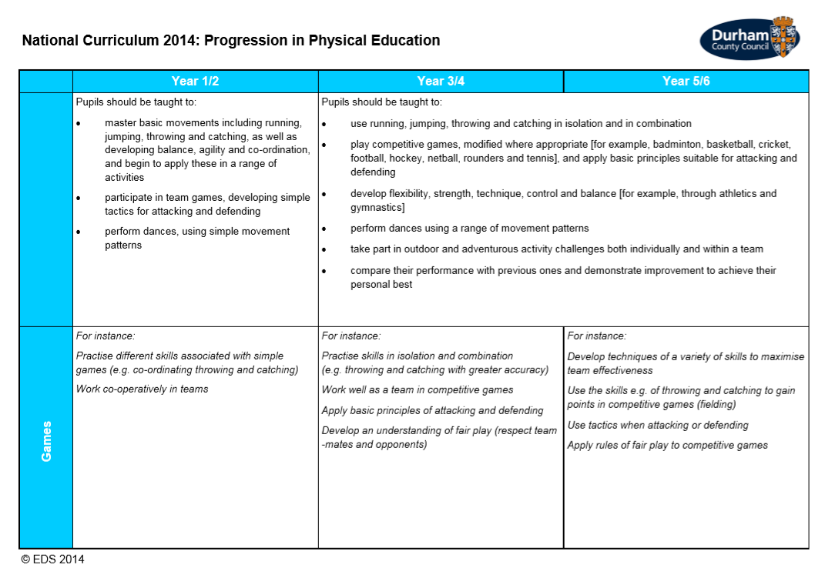

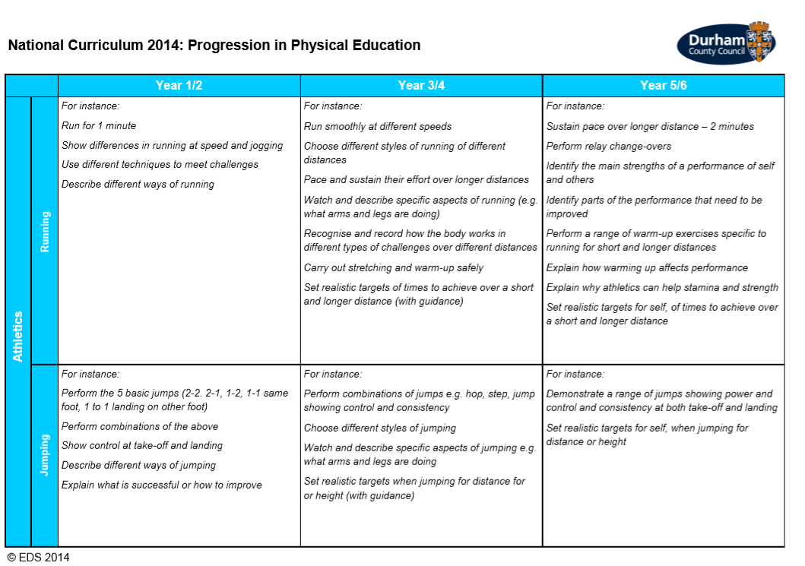

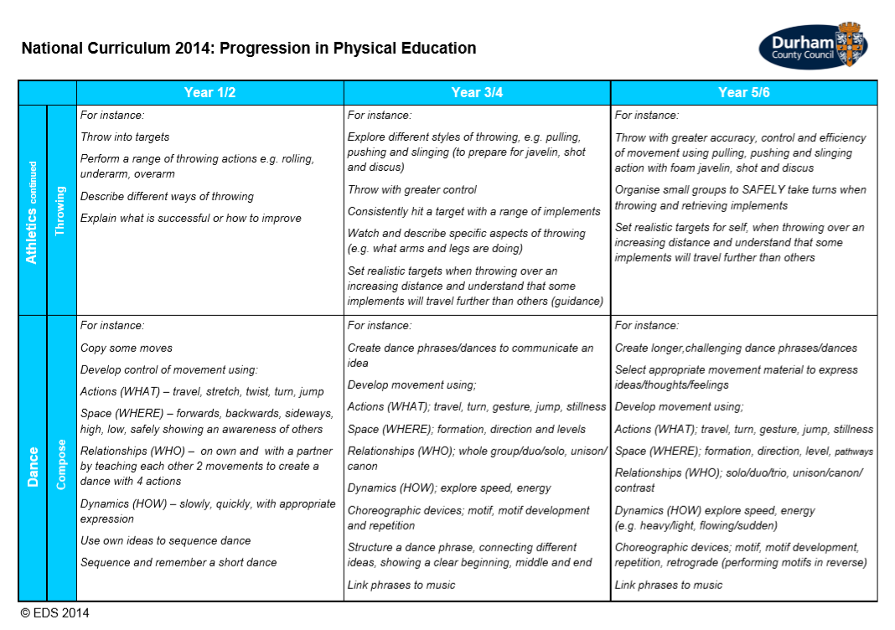
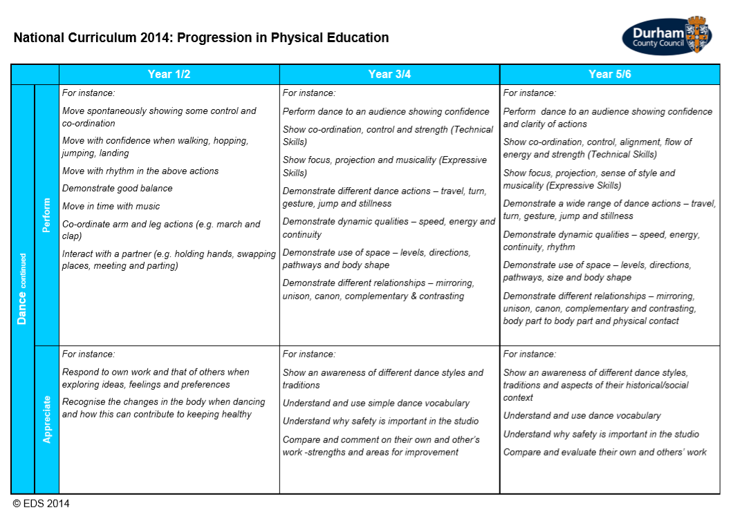

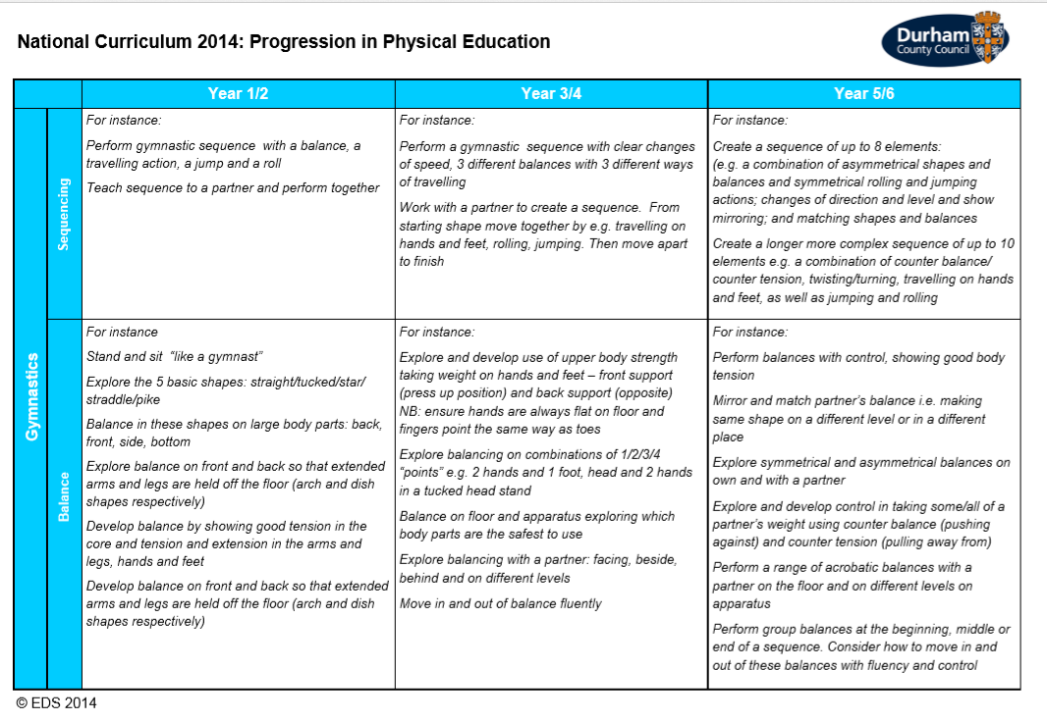

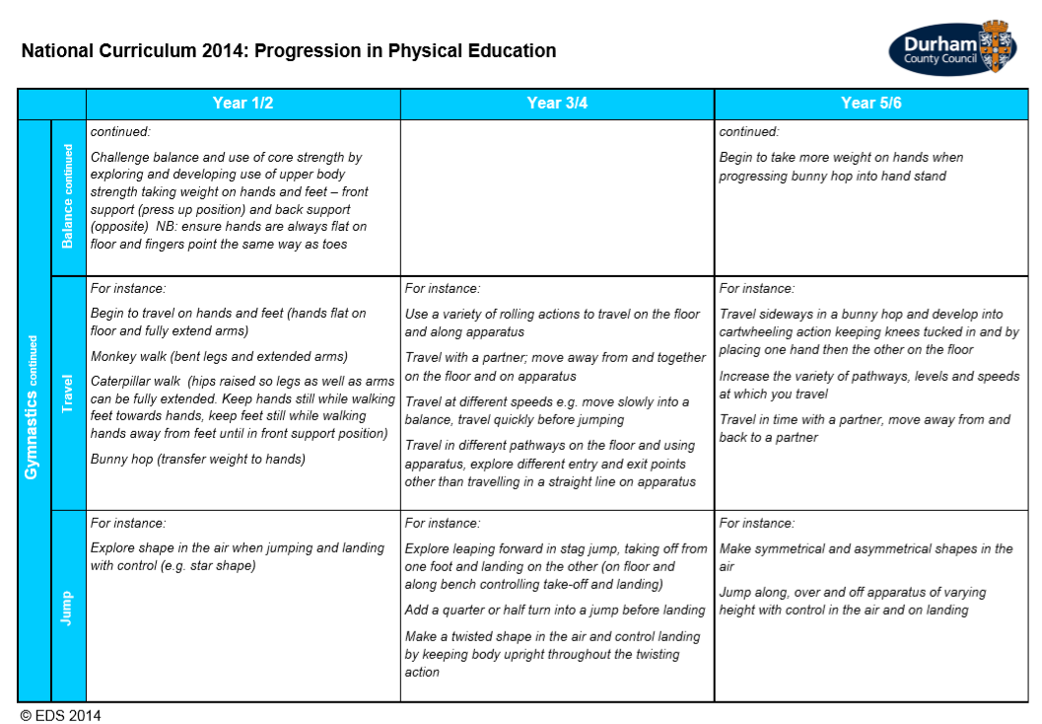

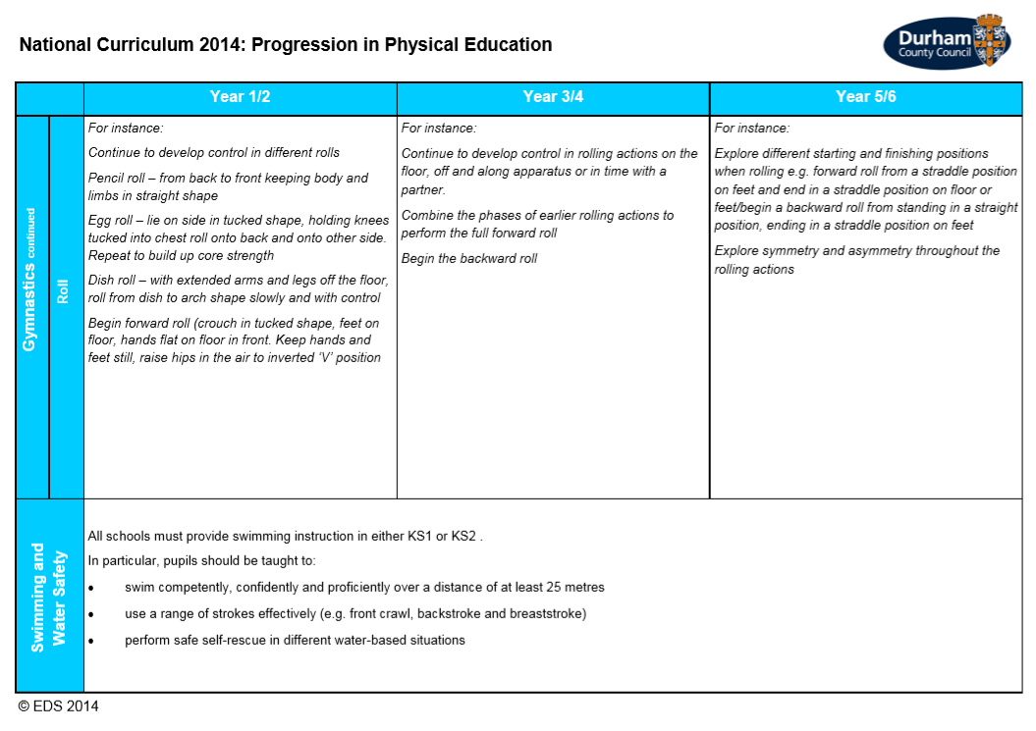

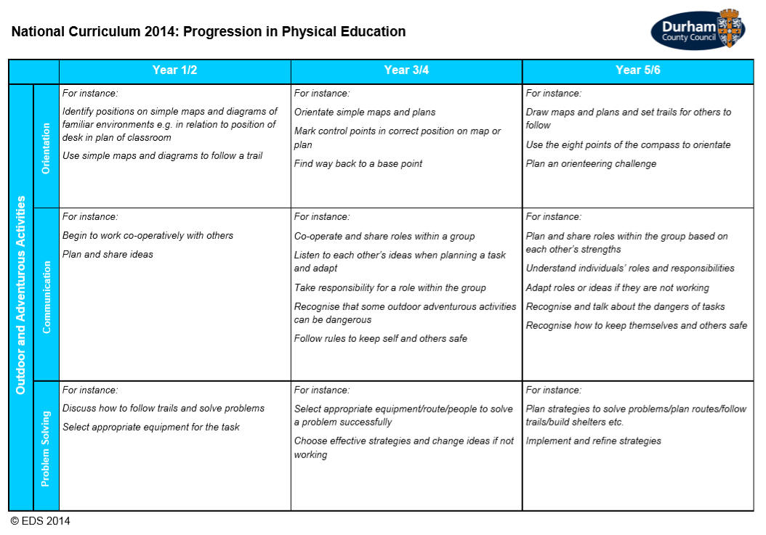

Policy to be reviewed annually.

