Welcome to Cestria Primary School

Firstly, welcome to our school, we can’t wait to welcome your child into Reception and begin their learning journey with us…
Starting School
In view of the age of the children, it is school policy to introduce them gradually into the classroom. Your child will be attending school on the following dates and times.
Week 1:
Thursday 5th September – Friday 6th September 9.30am-2pm – including lunch
During the first week the children will be met at the main entrance by the Early Years team. The door will not open until 9.30am.
At the end of the session the children will be brought out via the main entrance.

Week 2:
Monday 9th September onwards
The children will be in school full time from Monday 9th September. We will confirm the start and finish times. Children will enter via the middle entrance gates and they are picked up from the main entrance.

How we work
We have two Reception classes and a shared classroom. Classes will be allocated at the end of the induction period. All children use the same unit and have access to all of the areas. At Cestria we ensure we offer a high quality and challenging environment which caters to children’s needs and the way in which they learn best. We offer a stimulating environment where the children can freely select resources for child-initiated learning, as well as offering a rich curriculum of adult directed teaching by our highly experienced and dedicated staff.

This learning takes places within our reception unit which consists of three classrooms and an outdoor decked area which are all connected to allow the children to flow between them.
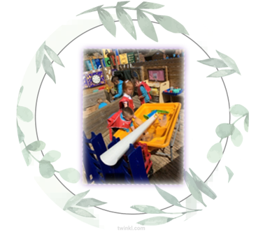
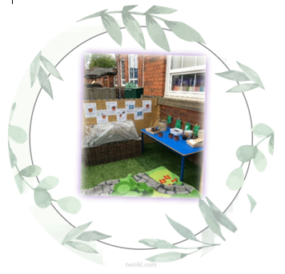

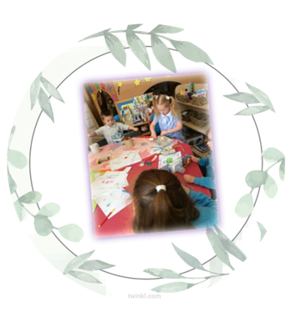

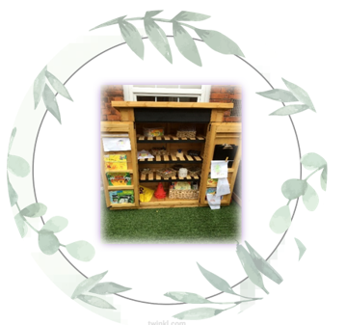
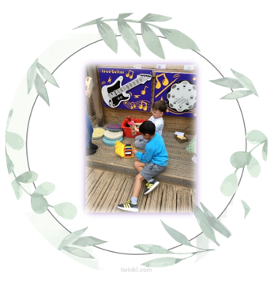
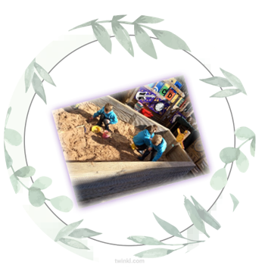

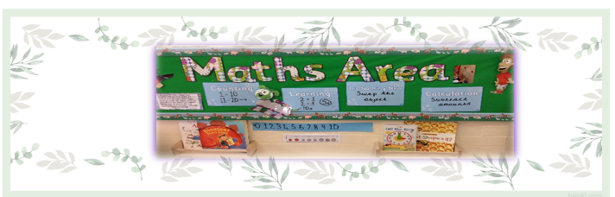
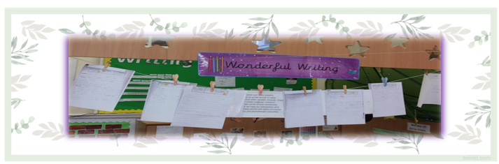
Throughout the course of the day the children participate in group time which focuses on developing phonics, mathematical, English and physical skills. We follow ‘Read Write, Inc Phonics’ and have developed ‘Big Maths’ for these areas *.
We do reading daily and change guided reading books weekly for the children to take home. More structured activities are introduced as the children develop. Their progress is closely monitored so that each child works at an appropriate level and with a curriculum which suits their needs and work towards all of the early learning goals *.
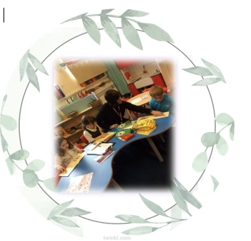
*https://www.bigmaths.com
http://www.ruthmiskin.com/en/resources/parent-tutorial-1-understanding-read-write-inc-phonics/
https://www.gov.uk/government/publications/early-years-foundation-stage-framework--2

Coming to school
Your child will be met at the school gate by a member of school staff. The aim is that all children say their goodbyes at the gate and come into school by themselves. Please clear the outside area as quickly as possible as it is the entrance used by all the children and it becomes very congested.
Going home
The children will be brought out of school by the Early Year’s Team via the main entrance. Please wait for your child within the school gates. Only adult’s that you have requested will be permitted to collect your child. Please let the office know if there is a change to persons permitted. Please bear in mind that this can take a while whilst we get to know all of the adults on the designated list, please be patient with us as safeguarding is priority.
When you need to see the teacher
There will be occasions when you need to meet with the class teacher. You can either:
- See the class teacher at the end of the day.
- Email the class teacher or leave a message with the school office for the class teacher to contact you.
- Use our messaging system via Dojo- Dojo’s will be answered between the hours of 8:30am- 4:30pm.
- If the matter is more complex or confidential, make an appointment with the Early Years Lead or if you need to you can arrange to meet with the Head Teacher.
When your child is ill
If your child is ill, please contact the school office before 9.30am, as any unexplained absence will be marked as unauthorised.
If you are unsure whether your child can attend school due to an illness please see NHS guidelines on contagiousness.
We can administer medicines but we require a written consent which clearly states the dose and frequency (medicines that are prescribed 4x a day). This form can be collected via the main office.
Please mark inhalers with your child’s name and the dosage details. A form will also need to be completed, this can be collected from the office.
School nurse
During your child’s first year in school his/her eyesight and hearing will be tested alongside their height and weight and you will be informed if there are any problems.
Parent Support Advisor
Claire Donnelly is our parent support adviser. She works with families to help deal with the challenges that family life can bring. She is available all year round, including school holidays. She offers practical support, advice and guidance on a wide range of issues, such as challenging behaviour, school attendance, supporting your child’s learning and any other issues that are important to you and your family. She can be contacted on 07771371391 or her email is c.donnelly101@peltonroseberry.durham.sch.uk
Dress Code

Our uniform comprises of:
- School hawaiian blue sweatshirt/cardigan/hoodie
- White polo top (with or without school badge)
- Grey/black PLAIN AND UNBRANDED leggings or
- Grey/black PLAIN AND UNBRANDED joggers or
- Grey/black school trousers or
- Grey/black school dress/pinafore or
- Grey/black school skirt
- Grey/white PLAIN socks or tights

Footwear must be grey/black with no obvious branding. Trainers can be worn but must be grey/black with no obvious branding.

- There is the option to wear a blue checked/*Etika blue dress in the summer term or school grey shorts NOT cycling shorts

PE Kit

You will be informed of your PE days by your class teacher. Children come to school wearing their PE kit on their PE days, this comprises of:
- School hawaiian blue sweatshirt/cardigan/hoodie
- White round neck t-shirt (with or without school badge)
- Grey/black PLAIN AND UNBRANDED leggings or
- Grey/black PLAIN AND UNBRANDED joggers or
- Grey/black PLAIN AND UNBRANDED school PE shorts NOT cycling shorts
- Grey/white PLAIN socks

Trainers must be white/black with no obvious branding.

If you are having difficulty sourcing a uniform in line with our policy we have a
selection of donated items which we will be happy for you to use.

*You can purchase our badged uniform from:
- Primary Schools | The School Outfit & Little Gems
- etika uniforms – The New Word In Ethical Uniforms
- SALTO UK

IMPORTANT
- Please can all uniform be NAMED
- Children do NOT need a school bag UNLESS they bring a packed lunch-we have limited space in school to store them and hopefully this will save some money
- Children do NOT need a pencil case, we provide everything that they need
- Children need to bring in a NAMED water bottle, filled, every day
- Children can wear a pair of small stud earrings ONLY-these must be covered/taken out for PE days

Reception take part in a variety of physical activities. When your child begins school your class teacher will let you know which day we have specified for PE. On this day please can your child come to school wearing jogging bottoms/leggings with their school polo top, jumper/hoody and appropriate footwear in line with above policy.
Children will be outside during all weathers so a pair of wellington boots (that can remain in school) are advised as well as an appropriate coat- please be aware that these may become muddy/messy.
Please be aware that clothing in Reception will get messy due to the nature of the children’s learning.
Home/School Liaison
Once your child is settled at school we will welcome parents into school for various events such as meetings, concerts, sports and fundraising events. We love to hear about what you have been doing with your children, you can send examples and pictures directly to their class teacher via Dojo. Your child will receive home learning every half term once they have settled in.
School Dinner
School dinners for all infant children are free. However, you may provide your child with a packed lunch. We follow a healthy school/nut free policy for a packed lunch-please see the website for further details. Please note that we need at least one week’s notice before children change from a school meal to packed lunch and vice versa. Please contact the school office for any further information.

Snack
Key Stage one Children are provided with a snack. This is a portion of fruit; however, you may provide your child with their own fruit snack if you wish.
Class Dojo
Dojo is an app that can be downloaded to your Phone or device. Teachers send messages, photographs, videos and rewards to celebrate the lovely work and activities that your child takes part in, as well as informing you of any events/activities that have taken place. Further information will be sent out once your child has started school.
Website
Our school website is www.cestria.durham.sch.uk. It holds a whole host of information about the school from diary dates to ways to support your children with their learning.

