CESTRIA PRIMARY SCHOOL

Maths Policy and Guidelines

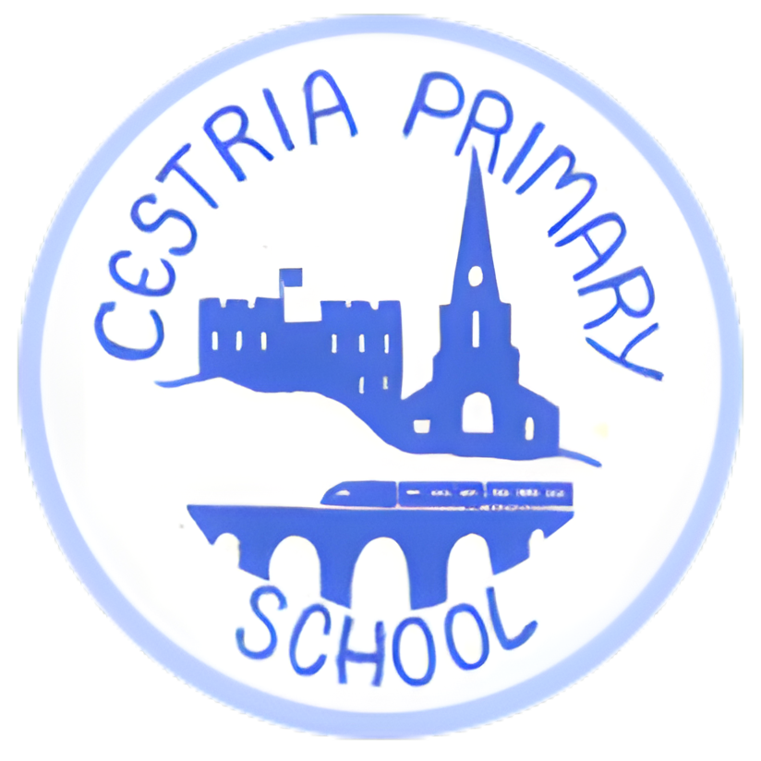

MATHS at Cestria

What is Cestria Maths?
We teach five hours of maths per week, across all year groups. Cestria Maths is developed from ‘Big Maths Online’ which is a teaching method that makes progress in Maths simple, fun and with clear progression. It ensures that children receive a highly positive approach to maths.

At Cestria we want to ensure we ‘get children properly numerate as they journey through school’, Cestria Maths provides an accurate and simple, but highly effective, framework that guarantees progress. This framework comprises of CLI (Counting, Learn Its, It’s Nothing New) followed by block teaching of topics in line with the National Curriculum.

We teach in 6 week blocks, with week 6 being an recap and review of previous teaching. This informs our formative assessment. Summative assessment is carried out 3 times a year.

The CLI resources provide progression at a glance as well as progression in detail. This ensures that all staff members teaching from the programme are following the same approach and therefore making learning clear for children. It also allows staff to fill in any gaps and to prevent future gaps from developing as all children make their way through the system with the necessary pre-requisite skills to meet new learning with further success and confidence.

During the block teaching, the children work at their own level as each topic starts with a ‘Starting Points Page’. We follow a *, **, *** approach with ** being the expected level for the year. No matter which * children are working on, they all access problem solving. Some children complete *** and then ‘Dive into Mastery’.

What is CLI?

Counting – Counting is done in many ways including counting forwards and backwards in various increments; work on place value and reading and ordering numbers.
Learn Its – Learn Its are 72 number facts which are learnt throughout the years from Reception to Year 4. They are split across the different terms so that each class works on a few Learn Its at a time, to ensure they are fully embedded. 36 are addition facts and 36 are multiplication facts.
It’s Nothing New – Children use a bank of facts and methods that they already have, to solve problems and that each step of progress is very small; children will use and apply their skills and methods to a range of different situations and problems.

Continuous Provision

Time – time is taught as part of the continuous provision in school. Each class have four clocks displayed and time is referred to continually throughout the day.
Measures/counting – this is reinforced through our bespoke cookery room, science hub and invention shed. This ensures children can apply skills learnt in real life situations that they can carry forward and use in the real world.

Planning
Here at Cestria all teachers follow the same planning map document which has been developed over time by the maths leads. This covers all aspects of the National Curriculum. We subscribe to BigMathsonline and Twinkl to resource maths.

Assessment
Staring Points: We want our children to be confident mathematicians. Each new unit starts with a recap of previous learning and the introduction of new learning. Whole class input covers a range of 1,2 and 3 star activities (2 star is the expected level). This identifies a starting point for each child to work through, building on prior learning and leading to problem solving activities. Children then complete independent work matched to their individual level, this is monitored by the class teachers to ensure progression and challenge. This formative assessment is used alongside our 6 week teaching blocks to provide a summative assessment. Data is then collated and analysed by leads and put into school assessment grids. We then address any gaps in learning through targeted interventions which are also tracked to monitor progress.

Calculation
Our calculation policy is directly in line with Big Maths. All teachers use Big Maths column methods with the exception of subtraction which is the borrow and pay back method.
For more information, please visit the Big Maths Website: https://app.bigmaths.com/home

Maths coordinator: Mrs Kym Robson and Mrs Carole Devlin
Policy to be reviewed annually.

