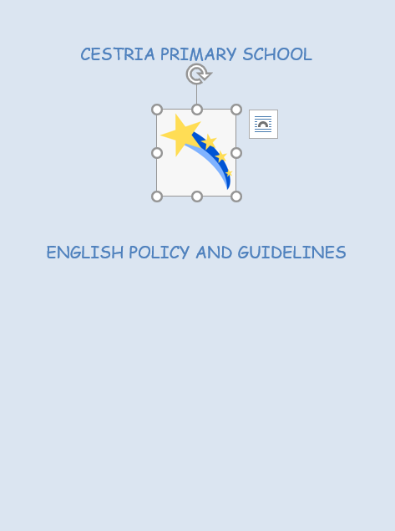

Cestria Primary School English Policy

Intent
That all children develop skills in oracy (speaking and listening), reading and writing that will enable them to express themselves creatively and imaginatively and communicate with others effectively and independently.
That they will become enthusiastic and critical readers, who understand how language works, and who are able to use this knowledge to choose and adapt what they say and write in different situations.
That all children will be able to utilise the skills, knowledge and understanding, taught in English, as a means to develop skills, knowledge and understanding across the whole curriculum.
Every child at Cestria Primary School, regardless of race, gender or special needs, will have equality of access to a broad and balanced English curriculum. All individuals will have the opportunity to experience success and develop an appreciation of their own cultural origins and that of others.

Teachers will set appropriate challenges for all pupils. Where attainment falls
significantly below expected levels, special provision will be made for additional support. Individual support plans will be drawn up for these children by teachers in conjunction with the SEND lead.

Implementation
At Cestria, English is a fundamental and integral part of the school curriculum and is taught both as a discreet subject and across the wider curriculum.
It is a legal requirement that Literacy should form part of the primary school curriculum as described in the National Curriculum guidelines. The EYFS Profile and the new National Curriculum outline which areas should be covered in each year group from September 2014. Our ‘Assessment to Support Learning’ documents for Reading & Writing split key objectives into terms for each year group and form the basis of our scheme of work. Literacy basic skills are integral to all cross-curricular work and, as such, are embedded throughout all learning.
Therefore, we provide a wide range of learning experiences, which enable children to develop in the following aspects of English:

Oracy:

Children at Cestria
- Have the opportunity to develop speaking and listening skills across all curriculum areas.
- Participate in a variety of planned oracy opportunities across all age phases. These include participation in immersive day activities and tasks within the curriculum rooms, which are designed to have a strong oracy component.
- Encounter a range of situations, audiences and activities designed to develop competence, accuracy and confidence in spoken language and to appreciate that different contexts may require different linguistic responses.
- Develop their oral abilities at their own levels, learning to structure descriptions and explanations and develop their understanding through speculating, hypothesising and exploring ideas.
- Develop listening and comprehension skills through a variety of means.
- Express opinions, articulate feelings and formulate appropriate responses to increasingly complex instructions and questions, justifying arguments where necessary.
- Respond orally to a range of written genres and varied stimuli. In EYFS and KS1, through story time activities (see appendix A), in KS2, through in-depth study of class novels and through news/assembly activities (see appendix B)
- Discuss and evaluate their own work.
- Collaboratively plan activities, considering and evaluating different viewpoints and building on the contributions of others.
- Retell stories and recite poems, which are known by heart.
- Respond to increasingly complex instructions and viewpoints, asking and answering questions and justifying actions and opinions.

The school facilitates oracy development by:
- Providing an example of clear diction, Standard English, accurate instructions, reasoned argument, imaginative language and considerate attention to speakers.
- Planning opportunities to regularly develop spoken language within the classroom, including collaborative discussion work, debates and question and answer sessions.
- Being aware that listening is a skill which increasingly needs to be taught to children and providing specifically designed activities to this end.

(see appendix C : Promoting Oracy)

Reading:

Children at Cestria
- Develop the ability to read aloud to others with appropriate fluency, accuracy, intonation, expression and inflection.
- Develop different strategies for approaching reading.
- Develop comprehension strategies: the ability to skim & scan, work out the meaning of new vocabulary, predict, evaluate, deduce and infer.
- Read a varied selection of texts and different genres
- Use reading as a means of information gathering and retrieval.
- Use their reading skills as an integral part of their learning throughout the entire curriculum.

The school facilitates reading development by:
- Providing a clearly structured phonological approach to reading in EYFS and KS1 - as well as, for some pupils, in KS2. (see appendix D),
- Using a reading scheme that closely matches every child’s reading ability and phonic level (RWI phonics books and Oxford Reading Tree), which is assessed every half term by teachers to ensure children are on the correct level. Teachers use the NC objectives to assess this.
- The children in the bottom 20% for reading in every year group are in targeted interventions that require reading 3 times per week (Lexia, RWI, Reading Buddy interventions)
- Ensuring other approaches are utilized for those pupils who do not respond to a phonological approach e.g. Whole word approach,
- Developing key reading comprehension strategies through a range of approaches, including: 'Tell me', 'OWI', timed reading challenges (KS2) and through the Hamilton Trust English scheme.
- Sharing stories through daily story time (EYFS & KS1), within English lessons including Guided Reading and Comprehension lessons using Hamilton Trust resources (KS2)
- Carrying out regular in-depth study of a ‘class novel' and using it to develop skills in all aspects of English.
- Providing regular research opportunities through the use of dictionaries or thesauruses, atlases, other information books, the use of the Edwardian library (KS2) and ICT based resources - both within English lessons and across the wider curriculum.
- Valuing books by providing attractively presented and readily accessible reading areas.
- Encouraging reading for pleasure through use of the class library, dedicated reading areas and by arranging visits to the local library.
- Encouraging children to continue the reading process at home, by providing suitable 'home reading' books and through initiatives such as the Summer Reading Challenge Competition (July 2022), book swap events, Cestria Reading Shed and The Reading Miles Challenge (wef November 2019).
- Using Oxford Reading Buddy to promote reading in an accessible and exciting way, including the use of rewards such as badges to collect.
- Weekly book-based assemblies across the whole school that link to personal development. The assemblies promote discussion in classes and across the school on a variety of issues.

Writing:

Children at Cestria
- Write in different contexts, in response to different stimuli and for different purposes and audiences.
- Write across different genres through a bespoke wriitng curriculum that includes elements of the Hamilton Trust scheme and ensures coverage of writing objectives.
- Use examples of writing within shared texts as a model for own writing.
- Are made aware of the conventions of writing, including vocabulary, grammar, punctuation and spelling, in order to write extensively and accurately in all areas of the curriculum.
- Work both individually and collaboratively on written tasks.
- Explore drafting, redrafting and editing their work when appropriate, including the use of talk partners, dictionaries and thesauruses
- Form letters correctly, leading to a fluent and legible handwriting style.
- Become familiar and adept in the appropriate uses of ICT to enhance the presentation of their writing.
The school facilitates reading development by:
- Highlighting writing as an important and valuable tool for all aspects of a child’s education.
- Modelling writing - sharing and discussing the process as they write.
- Responding positively and with interest to all attempts at writing.
- Providing an approach to writing tasks, through the use of Hamilton Trust planning and resources, to guide children through stages of the writing process.
- Providing a healthy writing environment, including experimental or emergent writing opportunities for EYFS and Key Stage 1.
- Teaching handwriting on a regular basis from EYFS, demonstrating correct pencil grip and letter formation, linking this with the reinforcement of spelling when appropriate. (See appendix E)
- Teaching and reinforcing correct spelling through the Purple Mash spelling scheme which covers all NC spelling objectives throughout the school. Sessions are taught in short, daily discrete sessions to ensure children are being exposed to spelling regularly (See appendix F Teaching Spelling)
- Teaching the statutory rules of grammar and punctuation, increasing knowledge, understanding and application progressively, as appropriate.
- Teaching the statutory rules of spelling through the use of Purple Mash Spelling scheme.
- Ensuring that expectations for writing are consistent across all subjects.

Impact
At Cestria, we monitor progress in English through a range of assessment methods:
- Daily interactions within lessons. Not only is Oracy a key element of English work itself, by talking to the children, we are able to use it to gauge their progress in other aspects of English.
- As a school, we have developed a range of AfL opportunities to use within lessons, together with a number of exit strategies to monitor children's learning during each lesson.
- Our marking/feedback system is able to accurately assess pupils' progress in relation to NC objectives or ELG as well as pinpoint the next steps for their learning. For every Hamilton Trust unit there is a ‘composition’ unit that is assessed using an ‘exit ticket’. This allows for regular quality assessment and marking with meaningful targets for children.
- Self assessment opportunities - particularly within writing tasks, and peer assessment opportunities - using talk partners to help review their work. Pupils are encouraged to use the exit tickets as a guide for how to be successful in their writing.
- Internal tracking systems. These are based on more formal assessments including standardised reading tests (Salford and RWI phonics) and Purple Mash spelling tests.
- Summative assessments at the end of Key Stages
- Keeping records of children’s achievements through the marking of reading activities within Comprehension lessons.

Monitoring: The English subject leaders monitor teaching and learning through:
- Classroom observations
- Learning walks
- Work scrutiny
- Participation in monitoring of writing assessments – including regular pupil progress meetings
- Monitoring results of reading and writing assessments
- Tracking of individual children using test data and teacher assessments.
- Hearing children read.
- Informal discussions with staff and children

English policy to be reviewed annually.

Appendix A

KS1 Storytime

Step inside the story

Monday | Assembly  Focus on PSHE objectives:  Relationships, Healthy living, Celebrating difference, Dreams and Goals, Being Me, Changing Me
Tuesday | Observe/ Wonder/ Infer  Discussion around new text. Focus on questions the children may have and ways to find the answers.  Use pictures/ words to evoke curiosity about the new text.
Wednesday | EEF question grid  Use the question grid to scaffold learning. Ask simple questions about the story then move learning on using the higher order questioning.  Children may be challenged to come up with their own questions using the grid.
Thursday | Tell ME  Likes, dislikes, puzzles and patterns. Discussion around the text so far. Work in groups/ with partners to approach this in fun and interactive ways each week.
Friday | Role play/ Drama  The children have heard the story so it is their chance to become a character. Create scenes/ freeze frames/ conscience alley/ hot seating to explore the story in more depth.

Weekly Genres
Autumn | Narratives  Traditional tales  Stories with predictable language  Letters  Information text  Persuasive  Pattern and Rhyme  Different stories by the same author  Revisit as appropriate
Spring | Fantasy  Stories with familiar settings  Invitations  Diary  Recounts  Poems using the senses  Extended stories/ significant authors  Revisit as appropriate (from both terms)
Summer | Character setting/ description  Poems on a theme  Instructions  Stories form other cultures  Explanation texts  Fact writing  Revisit as appropriate (from all terms)

Appendix B

Key Stage 2 ‘Me & My World’
Using Current Affairs as a focus for Assemblies, PSHCE & Continuous Provision
This programme comprises of the following seven elements:
- A Newsround session: Watching & discussing issues raised by the day’s news. Discussion to include any relevant PSHCE strands highlighted by the broadcast (i.e. ‘Relationships’ Jigsaw piece linked to anti bullying week)
- ‘Book-Based Assembly’ session: Reading & discussing carefully selected books that reflect the professional development calendar, and the wider social issues experienced by young people.
- Three assemblies: these provide further focus on PSHCE issues raised by Newsround, key stage assembly or recent ‘Jigsaw’ work as appropriate to children’s needs.
- Assembly 1: Pupil voice assembly led by SLT – Focus on a topic from that week’s key focus (around school priorities). Allow children to express opinions and share ideas.
- Assembly 2: OWI: To link with the professional development calendar and to provide oracy opportunities, the children carry out an ‘Observe, Wonder, Infer’ activity as part of a ‘Book-Based Assembly’, based on a picture book with a supporting power point.
- Assembly 3: Tell Me approach: This is based on either a ‘Book-Based Assembly’ or photo of the week, as appropriate. Through discussion of their ‘likes, dislikes, puzzles & patterns’ the children explore their PSHCE in relation to current affairs.

Timetable:
Day | Assembly
Mon | Key stage assembly session
Tue | Assembly 1
Wed | Assembly 2
Thu | Assembly 3
Fri | Book Based Assembly *
*Year groups may change day of Book Based Assembly depending on immersive day.

Appendix C

Oracy Guidelines:

“Reading and writing float on a sea of talk”
James Britton (1983)

Since our involvement in the NE Literacy Campaign (An EEF project) we have raised the profile of Oracy in our curriculum.

Research suggests:
- Good language skills are a strong predictor of later academic success
- 10% of children have language and communication difficulties
- Communication difficulties are a barrier to accessing the curriculum
- Children with poor language development at 5 are at substantial risk of low achievement at 7 years and beyond
A Chance to Talk

“ Language development, which begins with talk, is central to all learning…..Speaking and listening matter for employability and social life, so having the confidence and skill to communicate with others orally is most important …”
Meeting High Expectations

In accordance with EEF guidelines, we seek to 'develop pupils' speaking and listening skills and a wider understanding of language' because 'a focus on developing oral language skills is especially important for the development of reading and writing skills at this age.'

Focusing on all language will:
- Support development of comprehension skills;
- Develop critical language knowledge;
- Develop expressive language capabilities;
- Support for writing.

We feel that it is vital to provide children with the opportunity to extend their vocabulary. We aim to achieve this by:
- Providing exposure to a new and challenging vocabulary;
- Ensuring a repetition of a new vocabulary in context;
- Exploring vocabulary linked to current topics across the curriculum;
- Providing rich and varied opportunities to practice using new vocabulary.

The Promote a culture of "talk in school". We encourage children to develop confidence and competence through:

- Teaching and assessing skills explicitly and directly;
- Integrating talk into the whole curriculum;
- Promoting 'real life' opportunities to participate in events
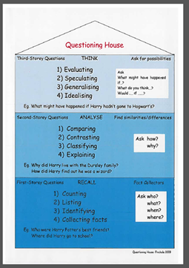
Strategies to promote effective talk:
- Jigsaw

- Memory maps

- Harvesting answers

- Preview/ Review

- Co-operative reading

- Oral story telling

- Modelling

- Scaffolding

- Talk frames / thinking maps

- Talk partners

- Tell me approach linked to reading activities

- Questioning grids

We aim to promote oracy skills across all curriculum areas. They also underpin: -
- Work in our curriculum rooms e.g. the cookery room
- Activities within our immersive days e.g. Wonderful Wednesday
- KS1 story time and
- KS2 Newsround sessions

Appendix D

Read Write Inc. Phonics

CESTRIA PRIMARY SCHOOL READ WRITE INC. POLICY
AIMS AND OBJECTIVES:
All children will be taught to read and write through the Read Write Inc. Phonics programme. This programme is aimed at all pupils in Reception, Year 1 and Year 2 who are learning to read and write. Children are taught to:
• Decode letter-sound correspondences quickly and effortlessly, using their phonic knowledge and skills
• Read common exception words on sight
• Understand what they read
• Read aloud with fluency and expression
• Spell quickly and easily by segmenting the sounds in words

How we teach phonics:
- Daily sessions taught in ability groups.
- With passion - this is a very prescriptive programme. It is the energy, enthusiasm and passion that teachers put into the lesson that brings the teaching and learning to life.
- Focus on participation - a strong feature of RWI lessons is partner work and the partners ‘teaching’ each other. This is based on research which states that we learn 70% of what we talk about with our partner and 90% of what we teach.

PLANNING
Teachers and TAs must use planning from the ‘Speed Sound Lesson Plans’ Handbook for Phonics and the framework in the ‘Phonics Handbook’ .
Teachers and TAs are responsible for planning for and resourcing their RWI groups, with the support of the Phonics Leader as required. Each group should have a box of resources including:
• Small flashcards (Set 1, 2 and 3)
• Set of green words
• Set of red words
• Set of alien words

SEN AND MORE ABLE PUPILS
1:1/ small group interventions (as appropriate) should be organised for any child who is not making expected progress (identified through termly assessment and assessment for learning in class).

ASSESSMENT
Once children have completed the RWI programme, they should move on to English lessons based on the National Curriculum objectives.
MONITORING The Phonics Leader will:
• Ensure that RWI assessments are planned for and carried out for all Reception, Year 1 and Year 2 pupils every (every term).
• Organise children into ability groups for Phonics and assign a teacher or TA to each group based on assessments
• Model lessons for staff to observe.
• Organise support and training for staff.
• Organise for resources to be sent home and support parents as necessary.

READING BOOKS
- Every child in Reception and Year 1 ( and Year 2, where appropriate) will be given a RWI reading book to practise at home. The relevant level will be decided by the teacher/ TA leading the phonics group (and Phonics Leader, as appropriate).
- Books are to be returned weekly (or 3 times a week for focus children) and a new book is given if the child can discuss the story with a teacher/ TA.

Appendix E

Supporting Transcription - Handwriting

Transcription refers to the physical process of handwriting

According to the National Curriculum:
- It is essential that teaching develops pupils’ competence in transcription
- Writing .... depends on fluent legible and eventually speedy handwriting

According to EEF Guidelines we aim to promote fluent written transcription skills by encouraging extensive and effective practice

Since our involvement in the NE Literacy Campaign (An EEF project) we have revised our approach to the teaching of transcription by breaking the handwriting process into a series of discreet steps. This way, any support can be focused and relevant to the needs of individual pupils.

There are 6 basic steps to effective transcription:
- Pre- writing experience
- Letter formation
- Letter positioning
- Joining
- Fluency
- Speed

These 6 steps are then broken down as follows:

1. Pre writing:
- Gross motor skills - Core strength and stability – gross motor skills – linked to physical development
- Fine motor skills - Development of hand and finger strength. Control over smaller movements
- Perceptual skills – working with different shapes and sizes
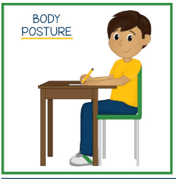
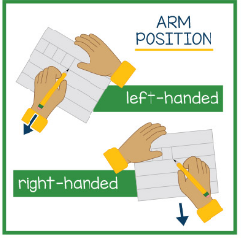

2. Letter formation: The four Letter families:
- Long ladder
- One arm robot
- Curly caterpillar
- Zigzag monster
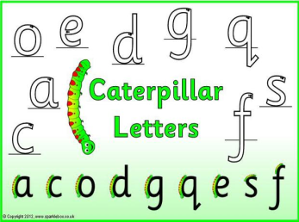
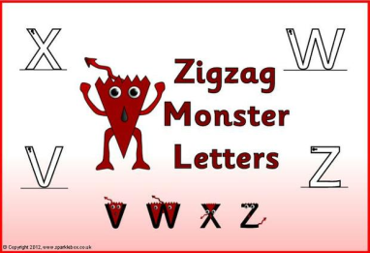
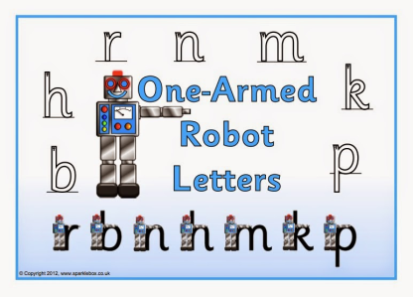
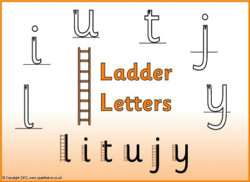

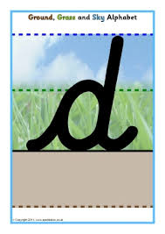
3. Letter positioning:
- Ground
- Grass
- Sky

Or:
- chicken
- monkey and
- giraffe letters

Plus spaces between letters

4. Joining letters
Three ways to teach joins
- Pattern making – standard handwriting patterns and linking pairs of letters
- Groups of letters – linked to phonics
- Three basic joins:
Up the hill – diagonal ( c-u, i-l)
Washing line – horizontal ( o-u, w-h)
Curly caterpillar joins (u-c, n-d)

5. & 6. Fluency & Speed
- Children need to free concentration space in their brains and to do this they need to stop thinking about letter formation (like you can walk without thinking)
- Regular and ongoing practice is important
- High expectations

Tackling issues
- What are the issues? – diagnosing the problem
- Sharing the issue – so you and the child know what it is
- Targeting the specific problem

letter size: 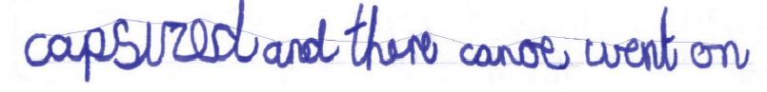
Shape:
- Use handwriting practice where children have done their very best version of a letter.
- Child identified their personal best.
- Encourage child to trace this and then put it over that letter in their writing – does it match? – if not – why not?
- The challenge is to make it match

Sitting;
- Are the letters sitting on the line
- Can the child see the lines?
- Can they identify lines where most of the letters are sitting on the line?
- How many lines have they got where this is the case?
- Can they up the number in the next piece of writing?

Spacing:
- The ooooo challenge
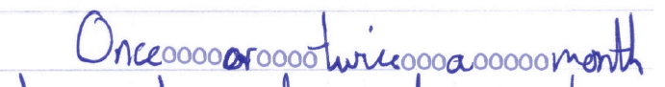
Slant:
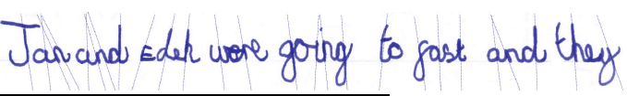

Sequence or string:
- Encourage children to keep pen on paper throughout joins
- Know which letters do not join – sometime b and p for example
- Letter strings can support spelling

Speed:
- Should only be a focus when all other aspects of writing are correct – otherwise you will end up reinforcing incorrect habits

Appendix F

Spelling

Purple Mash Spelling

10 minute daily spelling sessions (4 times a week – excluding immersive day)

Weekly structure:

Day 1 – Slideshow and quiz (Purple Mash resources)
Day 2 – Dictation (Purple Mash resources)
Day 3 – Look, say, cover, write, check (Purple Mash resources)
Day 4 – Common exception word/ Statutory spelling list focus (Teacher resources – ideas attached)

Include half termly spelling rules (from Purple Mash planning) AND termly word list spellings on homework sheet.

