

**Policy and Guidelines for**

**Promoting Positive Behaviour**

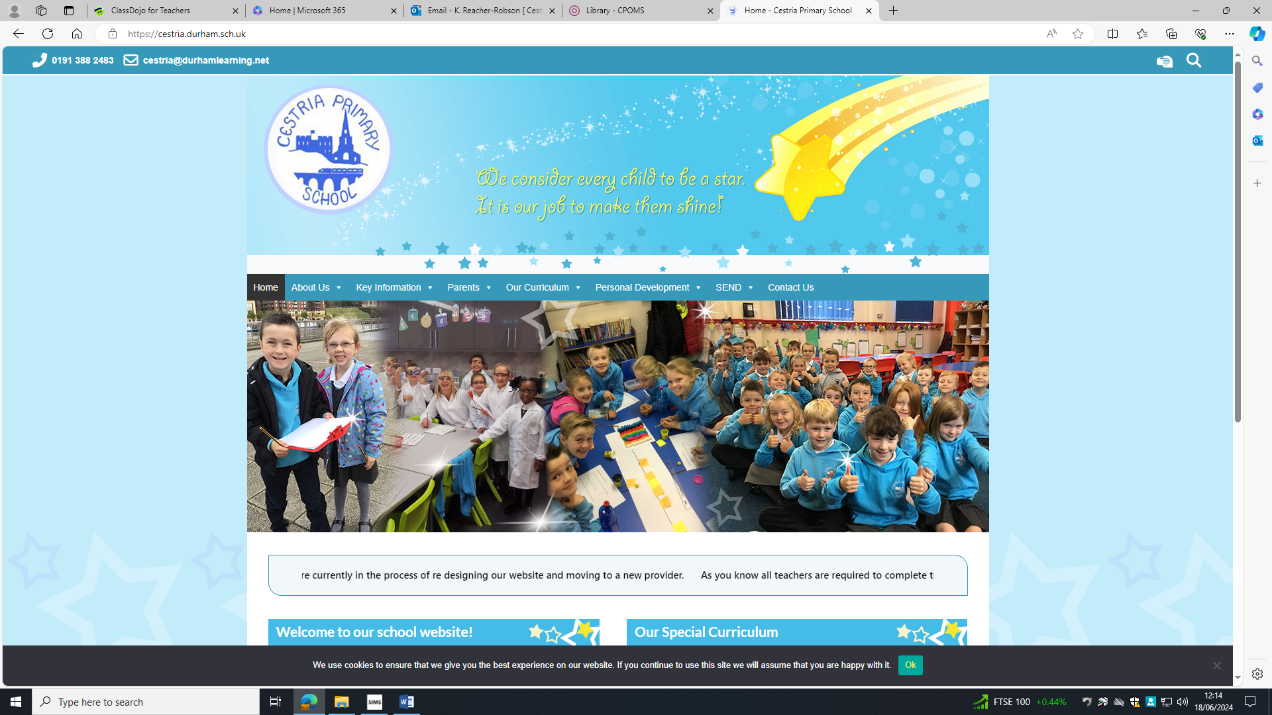

**Promoting Positive Behaviour Policy and Guidelines**

We want our school to be a happy and orderly environment in which children can learn and develop as caring and responsible people.

**At Cestria Primary School we:**

* Use positive praise as a form of acknowledging good behaviour and correcting unwanted behaviours
* Take a personal interest in the progress and welfare of every child
* Expect all staff to take responsibility for promoting good behaviour at all times
* Expect all staff and visitors to the school to act as positive role models
* Always take unacceptable behaviour seriously
* Believe that it is crucial to work closely with parents on managing behaviour issues when necessary and especially where there are persistent or serious difficulties
* Seek to identify and address any persistent difficulties
* Ensure that all necessary staff are informed of any issues/needs that may arise in order to ensure consistency of approach
* Greet children warmly regardless of any previous challenges – every day is a new start!
* Ensure that vulnerable children – such as those with special educational needs, physical or mental health needs - receive sensitive and well-matched behavioural support (see SEND section)

*We strive to ensure that all children are treated fairly by staff and other children. We want our learning environment to feel safe and secure, so that children can feel confident to be themselves and develop in their own way.*

*Our aims:   
• To understand what acceptable behaviour is and be educated and informed to make the right choices  
• To be tolerant and understanding with consideration for the rights, views and property of others  
• To develop a responsible and co-operative attitude towards work and towards their roles in society  
• To take a responsible interest in caring for their environment*

**Children work towards the school’s aims by:**  
* Following the school Behaviour Guide (above)  
* Making the decision to choose good behaviour  
* Attending school regularly and on time  
* Being organised: wearing uniform in line with school policy, wearing appropriate PE kit on PE days in line with school policy, handing in homework on time   
* Taking responsibility for their environment and for their own learning and conduct

**Teachers work towards the school’s aims by:**  
* Displaying and referring to ‘Zones of Regulation’ in classrooms  
* Providing challenging and stimulating lessons designed to engage pupils in their own learning and enable all children to reach the highest standards of personal achievement

* Recognising and being constantly aware of the needs of each individual child  
* Enabling children to take increasing responsibility for their own learning and behaviour  
* Ensuring learning is progressive and continuous  
* Being good role models: punctual, well prepared and organised  
* Taking quick, firm action to prevent one child inhibiting another’s progress  
* Providing opportunities for children to discuss appropriate behaviour  
* Working collaboratively with a shared philosophy

* The **Governing Body** has the responsibility of setting down general guidelines on standards of behaviour and of reviewing the effectiveness of the policy
* The Governors support the Senior Leadership Team in carrying out the policy

**Parents work towards the school’s aim by:**

* Encouraging their children to adhere to the policy

* Praising their child  
* Cooperating fully with the school when their child does not behave in line with the policy  
* Ensuring that children attend in good health, punctually and regularly including taking holidays in the designated holidays and not in term time

* Ensuring that their child has appropriate uniform, PE kit and that they support their child in completing homework and handing it in on designated days. If there are any issues with uniform or homework they should be reported to a member of the senior Leadership Team (Mrs Gowland – HT, Mrs Bentham – DHT or Mrs Robson)

We want our children to be a STAR:

* ***Show strength of character***
* ***Try your best in all you do***
* ***Always show kindness and respect***
* ***Remember to make good choices***

These are our core values and these attributes are what we hope to instil in our children ready for when they enter their next phase of life. We strive to create and maintain close partnership between children, parents and staff to develop children into lifelong learners and responsible citizens.

**What is Bullying?**

There is no legal definition of bullying but it is usually defined as behaviour which hurts someone emotionally or physically and is:

**S**everal

**T**imes

**O**n

**P**urpose

Bullying can take many forms including:

* physical assault
* social bullying
* threatening behaviour
* name calling
* cyberbullying

Our curriculum ensures that our children understand that there are different kinds of bullying and what to do if they feel that they are being bullied.

When a child or parent reports bullying to the school, we look at the reported incident individually.

Through ‘conflict resolution’ by staff, children are helped to understand the difference between ‘falling out’ and ‘bullying’.

On other occasions, the perpetrator may not be aware that their behaviour is actually bullying. They are perhaps modelling the behaviour of others, not understanding that it is wrong. In these circumstances, the intent to bully may not be present, but the impact and effect on the person being bullied will be no less severe because of this. It is explained to the child bullying that their behaviour is unacceptable and why.  Support is also given to the bullied child to ensure they understand what has happened and how they will be protected from further incidents.

If you suspect that your child is being bullied, do not hesitate to get in touch with a member of staff.  We will always do whatever we can to make a child's situation better.

***At Cestria we use the Zones of Regulation in every class***

## **WHAT ARE THE ZONES?**

The Zones of Regulation develops awareness of feelings, energy and alertness levels while exploring a variety of tools and strategies for regulation, prosocial skills, self-care, and overall wellness.  It helps us to think and talk about how we feel on the inside and sort these feelings into four coloured Zones, all of which are expected in life.  Once we understand our feelings and zones, we can learn to use tools/strategies to manage our different Zones in order to meet goals like doing schoolwork or other tasks, managing big feelings, and healthy relationships with others. The simple, common language and visual structure of The Zones of Regulation helps make the 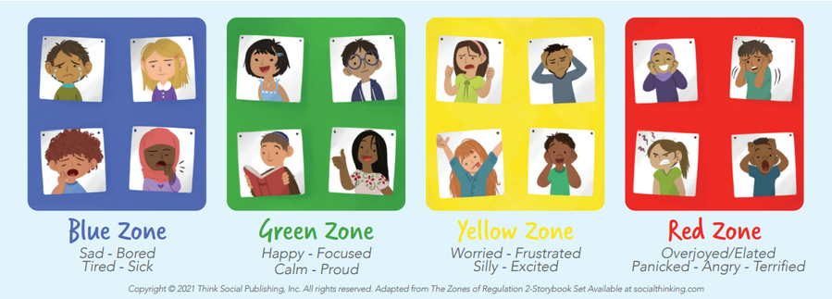complex skill of regulation more concrete for learners and those who support them.

**We deal with behaviours by (please note this does not always follow in order, some behaviours may be dealt with by going straight to 3/4):**

**Classroom Behaviour steps**

Step 1 - Teacher warnings

* A discreet reminder about positive behaviours
* A verbal warning/discussion (teachers must make it clear that the child has been given a warning, the reason why and how they can correct their behaviour linked to the zones of regulation)

Step 2 – Time out

* Have some time away from others during the school day (KS1 5 minutes, KS2 10 minutes) playtime missed **only** if the incident happens at playtime
* Explain why this has occurred, the feelings linked to behaviour and strategies that can be used to better deal with this
* Strategies then put in place by the class teacher to rectify the behaviour (including contacting parents if necessary)

Step 3 – Sent to behaviour lead/Head Teacher/Deputy Head Teacher

* Behaviour recording form filled in (see below) by the class teacher and handed to KS leads
* A discussion will be had with the teacher about all the strategies already in place
* We will work with the child on how better to deal with the situation that led to the behaviour presented

**Step 4 - Serious**

**If your behaviour is more serious…**

* **All steps previous to be followed**
* **If the behaviours involve another child they may be asked not to play with that child/or be seated away from them**
* **If the behaviours presented are disruptive then the child may be asked to spend some time in the corresponding year group classroom.**
* **Parents will be contacted**
* **External agencies may be contacted**
* **Consideration as to whether behaviours presented meet threshold for a behaviour plan (SEND-see below)**

**ALL SERIOUS INCIDENTS TO BE RECORDED ON SCHOOL RECORDING PORTAL – CPOMS by behaviour lead (see below)**

**Please note:**

* Parents may be contacted by their child’s class teacher at any stage (if it is repeated behaviour or to prevent poor behaviour escalating)
  + In the event of parents being contacted this needs to be face to face in the first instance, but if not possible, a phone call would suffice
* Staff will inform and work with parents of children with ongoing issues & support wherever necessary
* Children can also be sent to any member of the SLT as they are often a ‘free’ member of staff in school. They are also a ‘trusted adult’ who have positive relationships with children.
* Lunchtime supervisors also follow the same step approach. See below:

Step 1 – Staff warnings

* A verbal warning/discussion **away from others** (staff must make it clear that the child has been given a warning, the reason why and how they can correct their behaviour linked to the zones of regulation)

Step 2 – Time out

* Have some ‘time out’ during break (KS1 5 mins/KS2 10mins). This will be with an adult
* Explain why this has occurred, the feelings linked to behaviour and strategies that can be used to better deal with this

Step 3 – Sent to behaviour lead

* Behaviour recording form filled in (see below) by the lunchtime supervisor and handed to behaviour lead
* A discussion will be had about the behaviours that are present
* We will work with the child on how better to deal with the situation that led to the behaviour presented
* Lunchtime to be missed and spent with behaviour lead (KS1 5/KS2 10mins)

**Step 4 - Serious**

**If your behaviour is more serious…**

* **All steps previous to be followed**
* **If the behaviours involve another child they may be asked not to play with that child/or be seated away from them**
* **Sent to Head Teacher/Deputy Head Teacher**
* **Parents will be contacted**
* **External agencies may be contacted**

***Rewards***

***Lunchtime supervisors have separate rewards which are stickers. These can be given for a variety of reasons, including: healthy choices, trying new foods, showing kindness etc.***

**Remember every day is a new day and steps start fresh!**

**Nursery**

**In line with children’s age and development we have adapted the school stages as follows:**

Step 1 - Teacher warnings

* A discreet reminder about positive behaviours
* A verbal warning/discussion (teachers must make it clear that the child has been given a warning, the reason why and how they can correct their behaviour linked to the zones of regulation)

Step 2 – Time out

* Have some time away from others during the school day (designated space in the nursery classroom)
* Explain why this has occurred, the feelings linked to behaviour and strategies that can be used to better deal with this
* Strategies then put in place by the class teacher to rectify the behaviour (including contacting parents if necessary)

Step 3 – Sent to behaviour lead/Head Teacher/Deputy Head Teacher

* Behaviour recording form filled in (see below) by the class teacher and handed to KS leads
* A discussion will be had with the teacher about all the strategies already in place
* We will work with the child on how better to deal with the situation that led to the behaviour presented

**Step 4 - Serious**

**If your behaviour is more serious…**

* **All steps previous to be followed**
* **If the behaviours involve another child they may be asked not to play with that**
* **Parents will be contacted**
* **External agencies may be contacted**
* **Consideration as to whether behaviours presented meet threshold for a behaviour plan (SEND-see below)**

**ALL SERIOUS INCIDENTS TO BE RECORDED ON SCHOOL RECORDING PORTAL – CPOMS by behaviour lead (see below)**

**\*In Nursery we reward positive behaviours by collecting ‘stars in a jar’ to promote working together as a ‘Cestria Citizen’. In addition to this children may receive a sticker. This is in line with the age and stage of development of nursery aged children.**

**Rewards**

**Celebration Assembly**

On a Monday the Senior Leadership Team host a KS1/KS2 (bi weekly) assembly to celebrate achievements. This can include out of school achievements or achievements in school and anything relating to behaviour and attitudes.

We reinforce our STAR values throughout the school day.

We reward our children with a celebration of our core values at the end of each term.

**Restorative Approaches**

This is a more effective response than traditional punishments. Restorative approaches can change the emotional atmosphere in a school and lead to more positive relationships between pupils and between pupils and staff.

A restorative approach includes having a ‘restorative conversation’. These conversations may happen during the school day and staff will use restorative language and questions to allow children and young people to understand the impact of their behaviours. This includes listening skills, empathy, use of language including body language and understanding situations from another person’s point of view. We encourage pupils to accept responsibility for their actions, recognise the harm and upset caused and support them to find restorative responses to harmful actions. Developing positive, supportive relationships is key and these can be developed through activities such as circle time and peer support.

As part of the restorative approach, we will decide on an appropriate timescale to review incidents, check that issues have been resolved and that children and young people are happy and progressing well.

More serious incidents may require staff to hold a formal meeting and involve parents or families where appropriate. Examples of questions used in a formal meeting include:

* What happened?
* What were your thoughts at the time?
* What have been your thoughts since?
* Who has been affected by what happened?
* How have they been affected?
* What do you need to happen now?

**Supporting Children with Additional Needs**

Any child, at any time during their schooling, could experience a period of turbulence which may result in a change of behaviour. For a small number of children, they may have a specific underlying condition/need which should be considered. Approaches used to support these children include:

* Discussion with the child about their behaviours in line with zones of regulation
* Continued involvement from and liaison with parents
* Close liaison with the Special Educational Needs Co-ordinator (SENCo)/Deputy/Headteacher)
* Work suitably differentiated to match the child’s needs
* Providing additional support in liaison with the SENCo
* Involving external agencies
* Implementation of a behaviour plan
* Investigating options for alternative provision (dependent upon criteria, availability etc.)

**Rewards**

*Metacognition and self-regulation approaches to teaching support pupils to think about their own learning more explicitly, often by teaching them specific strategies for planning, monitoring, and evaluating their learning.*

*Self-regulated learning can be broken into three essential components:*

**cognition – the mental process involved in knowing, understanding, and learning;**

**metacognition – often defined as ​‘learning to learn’; and**

**motivation – willingness to engage our metacognitive and cognitive skills.**

Children with additional needs are to have a separate approach to promoting positive behaviour which is in line with their behaviour plan (see attached).

When children move up to their new class it is the responsibility of the class teacher to complete a ‘pupil passport’ (see below) to ensure all staff working with the child have a clear outline of the pupils needs and effective strategies.

At Cestria a child who is following a behaviour plan will have their own ‘Pom Pom’ jars. These will be in line with their specific targets and children will receive a pom pom in either a ‘thumbs up’ or a ‘thumbs down’ jar. They will be rewarded (in line with their behaviour plan) if they have more in their ’thumbs up’ jar.

This ensures that their steps and broken down into manageable parts, which can be rewarded/addressed immediately.

They have a visual representation of the choices they are making.

**Cestria Citizens**

In line with our personal development programme Cestria Citizens initiatives reinforce positive behaviours in line with this policy.

**Team Teach**

The safety of the children at Cestria Primary is vital. We have members of staff who are Team Teach trained this allows them to safely remove/restrain children who are a risk to themselves and others. Please see separate policy.

**Attendance**

Punctuality and good attendance, particularly the prevention of unauthorised attendance, is an integral part of our school policy on behaviour. Encouragement to attend school regularly emphasises positively the importance of school.

Parents will be reminded of their responsibilities for attendance and punctuality when necessary.

See separate attendance policy.

**In the Playground**

At lunchtimes and playtimes, our staff’s main purpose is to keep our children safe and happy If there are any behaviour issues lunchtime staff follow the policy and if it needs a member of teaching staff, the Behaviour Lead will deal with it. All members of lunchtime staff have books which they record any incidents and Behaviour Leads monitor the behaviour who then pass on information to Senior Management.

**Exclusion**

In most cases fixed or permanent exclusion will be the last resort after a range of measures have been tried to improve the pupil’s behaviour. A decision to exclude a child for a fixed period may be taken in response to serious breaches of the school’s behaviour policy, including persistent disruptive behaviour. If this occurs parents may be asked to remove their child for a specific, short term period while intervention strategies are put in place to help the child improve. Exclusions whether fixed term or permanent can only be imposed by the Headteacher or in his/her absence a designated representative, normally the Deputy Headteacher. Where exclusion is used the school conforms to the County Council Guidance. If a child is excluded for a period of less than 5 days the school will provide work – it is the parent’s responsibility to ensure the child completes the work and returns it to the school for marking (parents can be fined if their child is found in a public place during an exclusion). From Day 6 of an exclusion, temporary alternative arrangements for schooling, will be made for the child. In the event of a permanent exclusion the Local Authority will contact parents with details of the Day 6 provision.

**Behaviour Beyond the School Gate**

Children are expected to uphold the reputation of the school whenever they are out of school whether they are taking part in an official school trip/outing or wearing their uniform to and from school.

**Communicating the Behaviour Policy**

The Behaviour Policy is circulated to parents (via website) and staff and discussed with the children at least annually.

**Monitoring and Review**

The success of the school’s Behaviour Management Policy and provision is evaluated through school self-evaluation and reporting activities such as:

* Monitoring of classroom practice by the Leadership Team (including the Headteacher)
* Analysis of tracking data for individual children and for cohorts (class and individual logs)
* Incidents involving children with SEN will be recorded separately and passed on to the SENCO.

**Who was consulted?**

Governors, staff, children and parents were consulted during the development of this policy.

2025 Policy reviewed- Annually

Linked policies/procedures:

Anti-Bullying

Child Protection and Safeguarding

Allegations of Abuse against Teachers

and Other Staff

Complaints Procedure (responding to

Parents concerns)

**Pupil Passport**

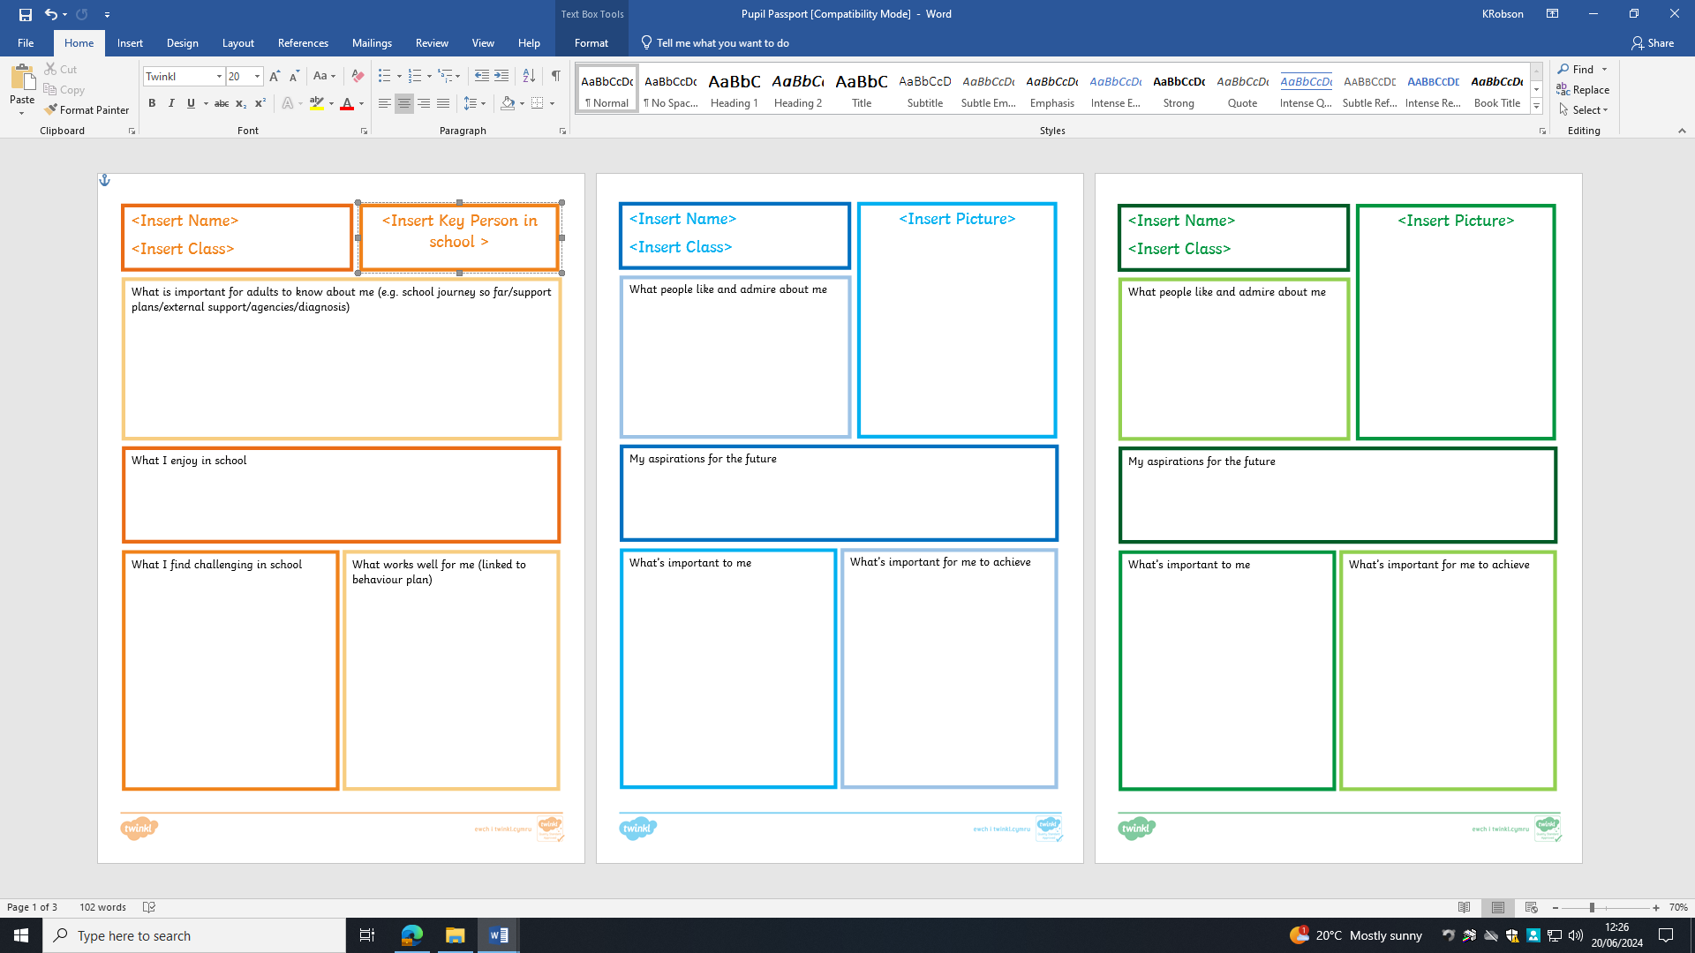

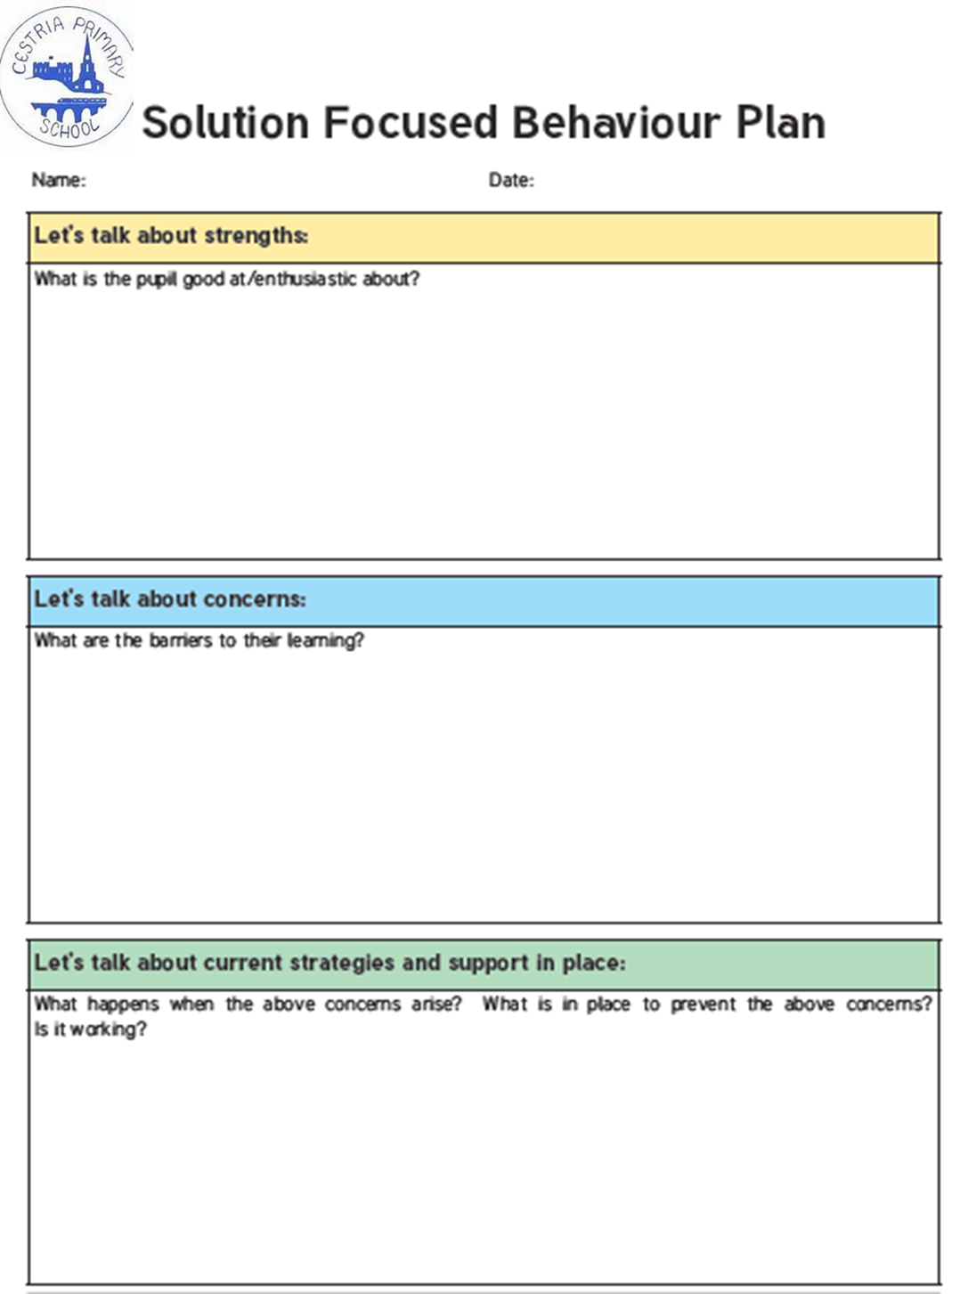**Behaviour Plan**

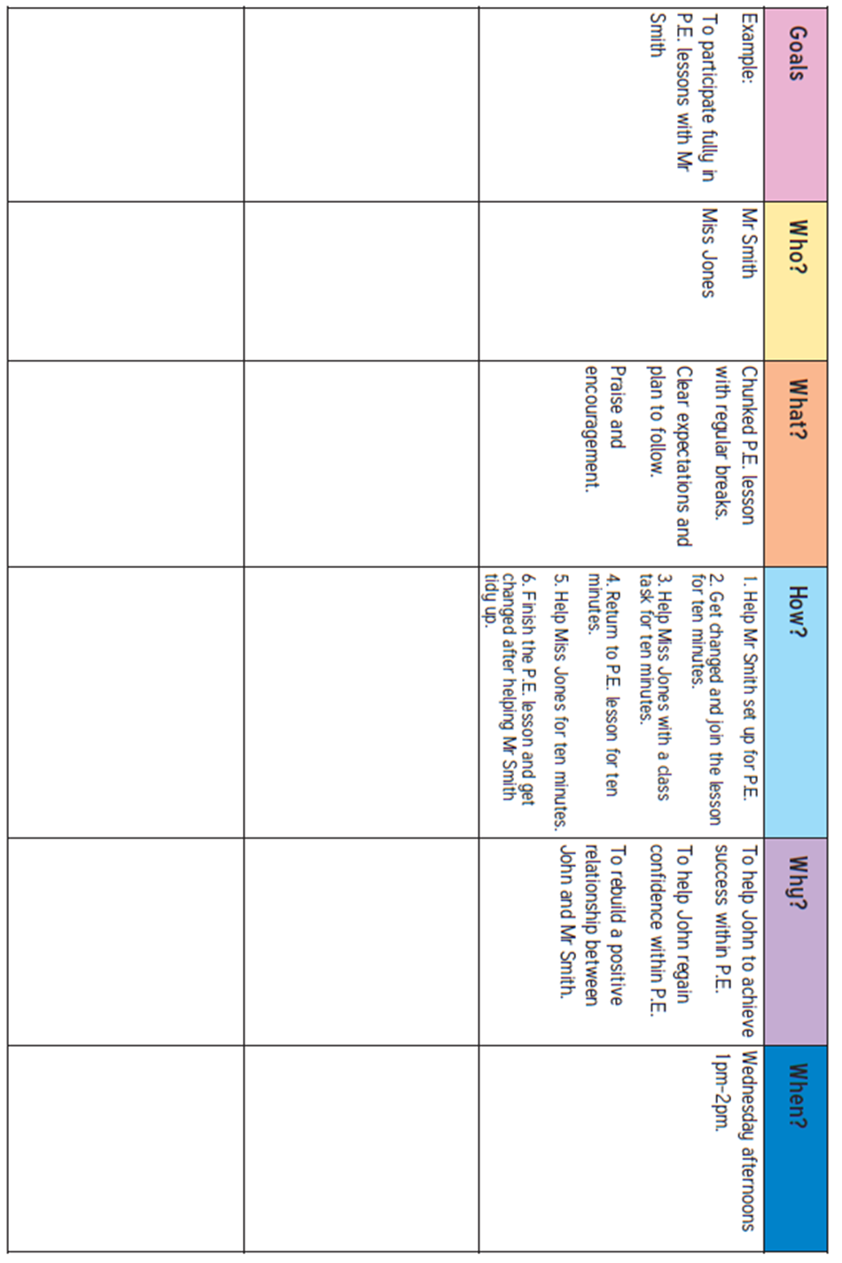

 **Behaviour Log**

*Reporting of behaviour incident (please indicate):*

***KS1– Miss Jayne Behenna,***

***KS2 – Mrs Lorraine Gowland/Mrs Nicola Bentham***

Nature of incident (please indicate):

|  |  |  |  |  |  |  |
| --- | --- | --- | --- | --- | --- | --- |
| racist | sexist | disability | homophobic  biphobic/  transphobic | use of derogatory language | bullying | inappropriate behaviour |
|  |  |  |  |  |  |  |

|  |  |
| --- | --- |
| Record of the incident: | Date: |
| Name of child: | SEN: Y/N |
|  | |
| Recorded by: | |
| Action Taken: | Date: |
|  | |
| Action taken by: | |