Pupil premium strategy statement
Cestria Primary School: 3 Year Strategy 2024-2027
This statement details our school’s use of pupil premium (and recovery premium) funding to help improve the attainment of our disadvantaged pupils. It outlines our pupil premium strategy, how we intend to spend the funding in this academic year and the effect that last year’s spending of pupil premium had within our school.
School overview

Detail | Data
School name | Cestria Primary School
Number of pupils in school 2024-25 | 392
Number of pupils in school 2025-26 | 392 (+ nursery)
Number of pupils in school 2026-7
Proportion (%) of pupil premium eligible pupils 2024-25 | 18% (71 children)
Proportion (%) of pupil premium eligible pupils 2025-26 | 17% (68 children)
Proportion (%) of pupil premium eligible pupils 2026-27
Academic year/years that our current pupil premium strategy plan covers (3 year plans are recommended) | 2024-2027
Date this statement was published | October 2024
Date on which it will be reviewed (Year 1) | October 2025
Date on which it will be reviewed (Year 2) | October 2026
Date on which it will be reviewed (Year 3) | October 2027
Statement authorised by | Lorraine Gowland
Pupil Premium Lead | Nicola Bentham
Governor | Steven Hardy

Funding overview

Detail | Amount
Pupil premium funding allocation this academic year | £116,930  £123,030
Total budget for this academic year  If your school is an academy in a trust that pools this funding, state the amount available to your school this academic year | £116,930  £123,030

Part A: Pupil premium strategy plan

Statement of intent
Our motto is ‘Every child is a star…it’s our job to make them shine’
At Cestria it is our aim to use Pupil Premium funding to improve and sustain higher attainment for our disadvantaged pupils that is comparable with that of non-disadvantaged nationally.
We are committed to help all children, irrespective of their background and circumstances, to achieve their full potential, broaden their horizons and raise their aspirations through:
- Promoting an ethos where all can succeed and achieve their goals irrespective of their background.
- Act early to intervene at the point need is identified therefore overcoming barriers to learning.
- Ensuring disadvantaged pupils are challenged at an appropriate level in the work they are set
- Adopt a whole school approach in which all staff take responsibility for disadvantaged pupils’ outcomes and raise expectations of what they can achieve.
- Providing high quality teaching and effective deployment of staff to support disadvantaged pupils.

Challenges: This details the key challenges to achievement that we have identified among our disadvantaged pupils.
Challenge number | Detail of challenge
1. | EYFS children enter school from a wide range of state and private nurseries within the community and beyond resulting in a wide range of starting points and experiences.
2. | Assessments indicate an attainment gap in reading between our disadvantaged pupils and their peers which is compounded by less engagement in supporting reading at home
3. | Some disadvantaged pupils including those entitled to Pupil Premium Plus, enter school having faced adversity, trauma, emotional and mental health needs within their family circumstances and require specific, targeted support.
4 | The Cultural Capital experiences of pupils eligible for Pupil Premium is low compared to their peers impacting on their aspirations and ability to reach their full potential.
5 | Attendance rates for disadvantaged pupils are not in line with non PP pupils

Intended outcomes
This explains the outcomes we are aiming for by the end of our current strategy plan, and how we will measure whether they have been achieved.
Intended outcome | Success criteria
- Narrow the gap between the proportion of disadvantaged children and non-disadvantaged children achieving the expected standards in Early Years | - To increase the proportion of Pupil Premium children achieving a Good Level of Development
- Disadvantaged pupils to make increased rates of progress in reading and to develop a love of reading | - To increase the proportion of disadvantaged children achieving at least the expected standard in reading (or above)  - Children develop a love of reading
3 To provide specific, targeted support to disadvantaged children (including those in receipt of Pupil Premium Plus funding) through effective trauma based CPD for staff. Staff to further develop their understanding of trauma based strategies to support those in need. | - Swift, targeted support offered to disadvantaged children and their families  - Disadvantage children enabled to reach their potential  - Staff trained in specialist field  - Improved understanding of trauma  - Strategies to support children embedded in school
- To enrich the Cultural Capital of our disadvantaged children through sustaining and further enhancing our personal development programme and enrichment curriculum to inspire children to achieve and raise their aspirations for their future | - Disadvantaged children access rich and varied experiences and opportunities.  - Disadvantaged children equipped with essential knowledge and experiences raising their aspirations for future success
5. To increase persistent attendance rates of disadvantaged pupils | - Sustain high rates of attendance  - Effective deployment of PSA providing targeted support

Activity in this academic year
This details how we intend to spend our pupil premium (and recovery premium funding) this academic year to address the challenges listed above.

Teaching (for example, CPD, recruitment and retention)
Budgeted cost: £48,500
Activity | Evidence that supports this approach | Challenge number(s) addressed
Quality First Teaching and Teaching Assistant Intervention across school  - Following the successful model applied in the EYFS department, increase staffing in KS1 including the introduction of an additional Y1 teaching space resulting in reduced group teaching sizes.  - Sustain the strategic deployment of Teaching Assistants across school focusing on specific needs and interventions. | Evidence indicates that high quality teaching is the most powerful way for schools to improve pupil attainment, particularly for socio-economically disadvantaged students.  EEF Guide to Pupil Premium  Well-evidenced teaching assistant interventions can be targeted at pupils that require additional support and can help previously low attaining pupils overcome barriers to learning and ‘catch up’ with previously higher attaining pupils.  EEF Toolkit: Teaching Assistant Intervention – additional 4 months progress | 1, 2, 3
Continual Professional Development –  Provide highly effective CPD across the school for all staff robustly linked to the school improvement plan: | Ensure that professional development effectively builds knowledge, motivates staff, develops teaching techniques, and embeds practice – ensure robust links to SEF/SIP  EEF: Effective Professional Development  TDT research found that: Teachers are most likely to improve when they engage in sustained improvement programmes over a period of two terms or longer. | 1, 2, 3, 5

Targeted academic support (for example, tutoring, one-to-one support structured interventions)
Budgeted cost: £18,500
Activity | Evidence that supports this approach | Challenge number(s) addressed
EYFS:  Ensure the focused and timely delivery of the Communications and Language Intervention - BLAST: Boosting Language Auditory Skills and Talking | Children who receive the communication and language intervention make about six months of additional progress, but some studies show slightly larger effects from disadvantaged backgrounds.  EEF Toolkit: Communication and Language approaches – additional 6 months progress  Well-evidenced teaching assistant interventions can be targeted at pupils that require additional support and can help previously low attaining pupils overcome barriers to learning and ‘catch up’ with previously higher attaining pupils.  EEF Toolkit: Teaching Assistant Intervention – additional 4 months progress  The average impact of Oral language interventions is approximately an additional six months’ progress over the course of a year. Some studies also often report improved classroom climate and fewer behavioural issues following work on oral language.  EEF Toolkit: Oral language Interventions +6 months | 1
Reading:  Targeted support in reading for the lower 20% across school  - RWI training for new staff  - Further extend reading materials across school  - Targeted use of reading hub to provide an engaging reading space  - Use of Teaching Assistants to provide targeted support according to need  - Further develop home reading liaison | EEF research shows that: Phonics approaches have been consistently found to be effective in supporting younger readers to master the basics of reading, with an average impact of an additional four months’ progress.  Reading comprehension strategies are high impact on average (EEF Reading Comprehension +6 months). Alongside phonics it is a crucial component of early reading instruction.  Parental engagement has a positive impact on average of 4 months’ additional progress Disadvantaged pupils are less likely to benefit from having a space to conduct home learning. Evidence suggests that disadvantaged pupils make less academic progress. By designing and delivering effective approaches to support parental engagement, schools may be able to mitigate some of these causes of educational disadvantage, supporting parents to assist their children’s learning or their self-regulation, as well as specific skills, such as reading. | 2
- Pupil Premium Plus:  - Arrange trauma based CPD  - Implement and embed strategies across school to provide targeted support to identified children and their families | Trauma-informed practice in schools requires educators to recognise the prevalence, impact and indicators of childhood trauma and to be aware of student behaviour in ways that support traumatised youngsters without retraumatising them (Fancourt, 2019)  Metacognition and self-regulation approaches to teaching support pupils to think about their own learning more explicitly, often by teaching them specific strategies for planning, monitoring, and evaluating their learning.  Interventions are usually designed to give pupils a repertoire of strategies to choose from and the skills to select the most suitable strategy for a given learning task.  EEF Toolkit: Metacognition +7 months

Wider strategies (for example, related to attendance, behaviour, wellbeing)
Budgeted cost: £28,000
Activity | Evidence that supports this approach | Challenge number(s) addressed
Cultural Capital:  Further increase our enrichment activities across the whole school including:  - Engaging Curriculum  - Personal Development programme  - Cestria Citizens  - Curriculum Rooms  - Enhancements: Theatre Groups, Subsidised music tuition and educational visits  - Mental Health and Well Being – If U Care, Share | The Sutton Trust commissioned report ‘Subject to Background’, based on data produced through the Effective Pre-School, Primary and Secondary Education (EPPSE) project which found that bright disadvantaged children would be more likely to attain 3 A-Levels if, in addition to a high-quality education, they had enrichment and supportive home learning environments from a young age. This included reading books and going on educational outings.  Sutton Trust: Subject to Background report | 4.
Attendance: Increase persistent absence rates of disadvantaged pupils through:  - Effective CPD for all staff  - Deployment of PSA to support whole school approach  - Targeted support for identified children | DFE Pupils with good attendance records are more likely to achieve better grades | 5.

Part B: Review of outcomes in the previous academic year

Pupil premium strategy outcomes
This details the impact that our pupil premium activity had on pupils in the 2024 to 2025, 2025 to 2026 and 2026 to 2027 academic year.
Review Period 1:
TEACHING STRATEGIES:
Successful EYFS model adapted and implemented into Year 1 to create an additional learning space resulting in smaller class sizes. Focused quality first teaching within smaller groups impacting on Y1 phonics screening
- School: 86.6% National 80.4%.
- Of the Y1 PP cohort, 75% (6 out of 8) children met the threshold
- Appointment and redeployment across school of Teaching Assistants to support children with specific needs and focused interventions
- Quality First Teaching accompanied by high quality support from Teaching Assistants:
- KS2 Reading Exp+– 94.8% GD – 39.4%
- KS2 Writing Exp+ – 90% GD – 40%
- KS2 Maths Exp+ – 79.3% GD – 27.5%
- At Cestria, disadvantaged children achieve above non disadvantaged nationally in Reading, Writing and Maths
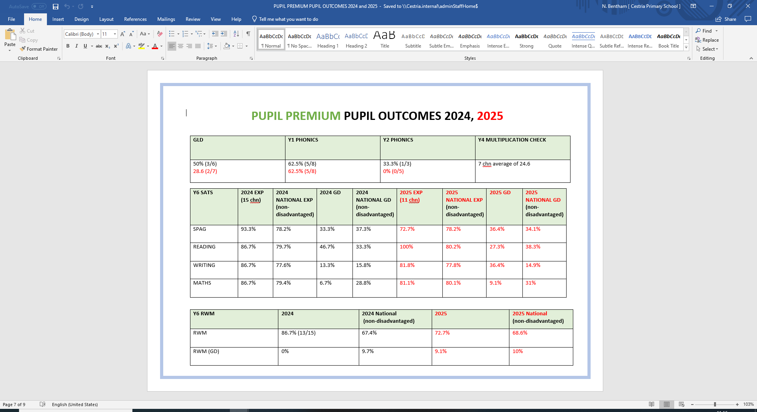

TARGETED INTERVENTION
- Successful implementation of BLAST programme in Reception leading to 84% of children achieving 2 in ELG for speaking
- Bespoke CPD in phonics, reading and comprehension designed and delivered for all staff – assessment refined to track reading and comprehension reading age
- Specific Read, Write, Inc training delivered to key staff ensuring continued fidelity to the scheme
- Focused reading interventions to target lowest 20% delivered across school with fidelity to Read, Write Inc
- Reading materials further expanded across school to increase volume of high interest, low level books (Project X)
- Use of Pupil Premium Plus: CPD focus on Trauma and Future Steps referral
WIDER STRATEGIES:
- Expansion of Personal Development Programme including Cestria Citizens and book based assemblies
- Development of curriculum rooms – Invention Shed, Media Room, Sunshine Room, science room to sustain delivery of motivational and practical activities
- Sustained and further enhanced offer of high interest clubs (free to all)
- High rates of attendance – attendance data monitored, and swift action taken to follow procedure and support offered by PSA for those families identified
- Intensive and sustained support for children and families from experienced PSA
- Appointed mental health and wellbeing lead to develop our offer even further
Use of Pupil Premium funding to subsidise music tuition, theatre groups and educational visits

END OF STARTEGY REVIEW 2027

Externally provided programmes
Please include the names of any non-DfE programmes that you purchased in the previous academic year. This will help the Department for Education identify which ones are popular in England
Programme | Provider

Service pupil premium funding (optional)
For schools that receive this funding, you may wish to provide the following information:
Measure | Details
How did you spend your service pupil premium allocation last academic year? | Significantly low number – not evaluated
What was the impact of that spending on service pupil premium eligible pupils? | Significantly low number – not evaluated

