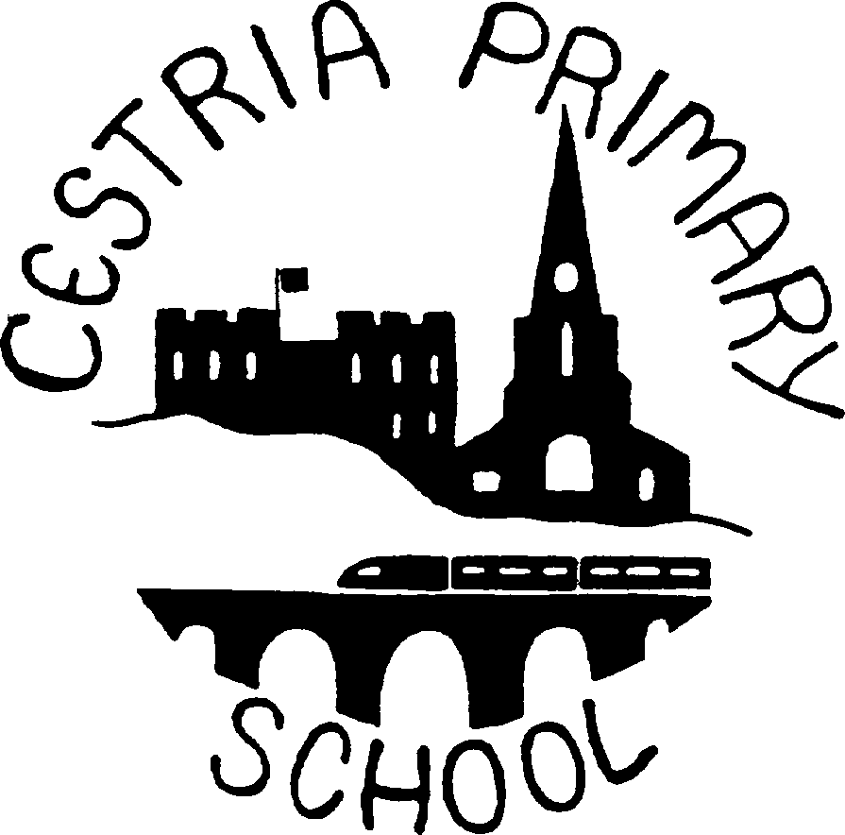

CESTRIA PRIMARY SCHOOL

POLICY AND GUIDELINES

ON

HISTORY

Reviewed annually – G Taylor

Intent - What do we aspire for our children?
At Cestria Primary School, we provide a high-quality history curriculum that has been carefully designed and sequenced to equip our children with a secure, coherent knowledge about British, local and world history. Curriculum content is delivered in sequenced chronological order, allowing children to develop their understanding of abstract historical concepts as they move through school. Our curriculum reflects our locality and endeavours to ensure children are knowledgeable about their locality’s history and the changes it has seen.
Through an enquiry-based approach, children are encouraged to ask and explore historically valid questions and report their findings by drawing on skills from across the curriculum. Alongside the development of substantive knowledge children develop their disciplinary skills to understand how historians use sources of evidence to construct knowledge about the past. Children will leave Cestria Primary School being knowledgeable about key people, events and time periods from the past and will weave these together to form informed, overarching historical narratives.

Implementation - How will we deliver the curriculum?
Each unit in our long-term plan is underpinned by rich, substantive knowledge and ambitious vocabulary. Units link both substantive and disciplinary knowledge to ensure children gain the capacity to construct historical arguments or analyse sources.
Topics have been planned carefully in Key Stage Two to ensure concepts are taught in chronological order to support children's understanding. Each unit of work has an emphasis on historical enquiry that allows children to ask questions, select and evaluate evidence and make judgments about the past. As well as developing a breadth of historical knowledge, we want our children to become skillful historians.
In addition, children deepen and extend their knowledge through museum visits, handling artefacts and engaging with visitors.

How do we teach how aspects of history connect with each other? - Historical Threads
Our curriculum has been planned to include key concepts or ‘threads,’ that children will repeatedly revisit throughout their time at Cestria Primary School. Our threads are settlement, conflict and disaster, societal change, and achievements. For example, in Year 4, children will encounter the concepts of invasion, societal change, settlement and invention when studying the Romans. In Year 5, children will revisit the concepts of societal change and invasion as they explore how Britain changed during the Dark Ages when the Anglo-Saxons arrived.

Age  Phase | Year Group | Topic Name | Historical Enquiry Question(s) Main | EYFS/National Curriculum Focus | Historical  Concepts | Threads
EYFS | RECEPTION | Understanding the World Past and Present | Begin to make sense of their own life-story and family’s history.  Comment on images of familiar situations in the past.  Compare and contrast characters from stories, including figures from the past. Talk about the lives of people around them and their roles in society.  Know some similarities and differences between things in the past and now, drawing on their experiences and what has been read in class.  Understand the past through settings, characters and events encountered in books read in class and storytelling. |  | Cause and effect/Change and continuity/Similarities and differences/Historical significance/Sources of evidence and historical interpretation. | Settlements, Conflict and Disaster, Societal change, Achievements
KS1 | YEAR 1 | Family History | Who was here before me? | Changes within living memory
KS1 | YEAR 1 | Local History | What was CLS like in the past? | Significant places in own locality
KS1 | YEAR 1 | Changing Holidays | What were holidays like in Edwardian times? | Changes within living memory
KS1 | YEAR 2 | Marvellous Messages | How has communication changed  overtime? | Events beyond living memory
KS1 | YEAR 2 | Local History | Why do we have a cathedral in Durham? | Significant people/places in own locality
KS1 | YEAR 2 | Explorers and Adventures | Who were the greatest explorers? | Lives of significant individuals
LOWER KS2 | YEAR 3 | Stone Age, Bronze Age & Iron Age | Which is more impressive – the Stone Age, the Bronze Age, or the Iron Age? | Changes in Britain from the Stone Age to the Iron Age
LOWER KS2 | YEAR 3 | Egyptians | What was life like for the Egyptians? | The achievements of the earliest civilizations
LOWER KS2 | YEAR 3 | Ancient Greece | Why do we remember the Ancient Greeks  today? | Ancient Greece – a study of Greek life and achievements and their influence on the western world.
LOWER KS2 | YEAR 4 | Romans | Were the Romans Remarkable? | The Roman Empire and its impact on Britain
LOWER KS2 | YEAR 4 | Local Study | What happened when the Romans came to CLS? | Local history study
LOWER KS2 | YEAR 4 | Anglo Saxons | Why did the Anglo Saxons come to  England? | Britain’s settlement by Anglo-Saxons and Scots
UPPER KS2 | YEAR 5 | Vikings | How vicious were the Vikings? | The Viking and Anglo-Saxon struggle for the kingdom of England
UPPER KS2 | YEAR 5 | Local Study | From Vikings – Normans what happened  in our area? | Local history study
UPPER KS2 | YEAR 5 | The Maya Civilisation | Who were the Maya and what happened to them? | A non-European society that provides contrasts with British history
UPPER KS2 | YEAR 6 | Britain since AD1066 | Was life awful for children in the past? | A study of an aspect or theme in British history that extends  pupils’ chronological knowledge beyond 1066
UPPER KS2 | YEAR 6 | Local Study | Who were the most significant individuals in the North of England? | Local history study
UPPER KS2 | YEAR 6 | Significant People in  British History | Who have been the most significant  people in British history? | A study of an aspect or theme in British history that extends  pupils’ chronological knowledge beyond 1066

How do we develop children’s chronological knowledge?
Pupils’ chronological knowledge is developed at Cestria Primary School using continuous provision timelines. Children explore the school timeline in lessons and in workbooks. This increases pupils’ knowledge of broad developments and historical periods and helps to develop their ‘mental timeline’ of the past.

How do we know children are making progress?
At Cestria Primary School we begin each topic by establishing a starting point from which new learning and understanding can be measured. We work in 6-week blocks (x2) to teach key substantive and disciplinary knowledge set out in the MTP. We know children are making progress in history as they know and remember more content that is set out in the MTP. Teachers use AFL to assess children’s:
- topic knowledge – the knowledge of the period/place/society they are studying
- chronological knowledge - the overview of major developments and periods to contextualise new knowledge.
- Knowledge of substantive concepts - concepts such as ‘empire,’ ‘civilisation 'and ‘societal
change.’
Children demonstrate their understanding of what has been taught by linking their knowledge to answer the enquiry question that was introduced at the start of the topic. Misconceptions are addressed at the start of lessons and at week 6 of the teaching block. Teachers reteach key substantive or disciplinary knowledge that is needed for children to progress in the next block or topic.

How do we provide for all learners?
History lessons at Cestria Primary School are inclusive, teachers make effective modifications or adjustments to lessons to minimise or reduce barriers to learning so that all pupils can participate and make progress.
Teachers may:
- provide individual or group support
- plan smaller steps within the lesson to support children in achieving the intended goal.
- provide a ‘parallel’ activity for pupils so that they can work towards the same lesson objectives as their peers, but in a different way – e.g. simplify complex language and imagery on websites.
- pre-teach vocabulary
- Scaffolding learning - Support could be visual, verbal, or written. E.g. Writing frames, partially completed examples, knowledge organisers, prompts, sentence starters.
- give additional time to complete tasks.

