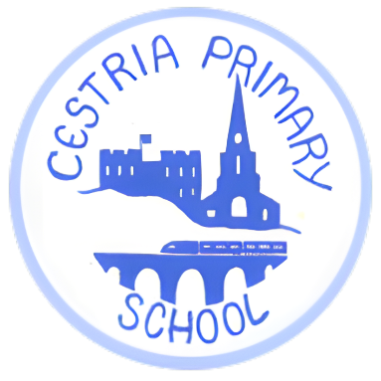
Packed Lunch Policy
1. Purpose
At Cestria we recognise that a healthy, varied and well-balanced diet is important for children's health, wellbeing, concentration and learning.
This policy sets out the expectations for packed lunches brought into school. It aims to ensure that packed lunches are nutritious, appropriate for a primary-school environment and safe for children with food allergies.
The policy applies to all children bringing a packed lunch to school, including packed lunches brought on school trips or for special activities.
2. Healthy Packed Lunches
We encourage parents and carers to provide a varied and well-balanced packed lunch which supports a healthy lifestyle.
A packed lunch should generally include a combination of:
- A starchy food such as bread, wrap, pasta, rice or similar.
- A source of protein such as chicken, egg, beans, pulses, cheese or another suitable alternative.
- Fruit and/or vegetables.
- A suitable dairy or dairy alternative where appropriate.
- A drink, preferably water.
Parents and carers are encouraged to vary the foods provided and to consider portion sizes appropriate for their child's age.
3. Foods Not Permitted
As a Healthy School, we ask families not to include foods that are particularly high in sugar, salt or saturated fat.
We encourage healthier alternatives such as fresh fruit, vegetables, plain crackers, breadsticks, yoghurt or other suitable options.
If a child brings an item that does not meet this policy, the school may remove the item from the child's lunch and return it to the parent/carer at the end of the school day.
4. Nut-Free Requirements and Benedict's Law
The school follows Benedict's Law in relation to the management of nuts in children's food.
Products containing nuts as an ingredient are not permitted in packed lunches.
Parents and carers must therefore check the ingredients list carefully before sending food into school.
For the purposes of this policy, where nuts are listed as an ingredient, the product must not be brought into school.
Precautionary allergen labelling
We recognise that food manufacturers may use precautionary statements such as:
- "May contain nuts"
- "May contain traces of nuts"
- "Made in a factory that also handles nuts"
Where a product does not contain nuts as an ingredient, but carries a precautionary statement of this type, it will generally be acceptable under this packed lunch policy, unless the school has specifically advised otherwise because of an individual child's medical/allergy requirements.
Parents and carers should always check the current ingredient and allergen information on packaging, as recipes and manufacturing processes can change.
If nuts are deliberately included as an ingredient, the product must not be brought into school.
5. Food Allergies and Individual Requirements
The school recognises that some children have diagnosed food allergies, intolerances or other medical dietary requirements.
Parents and carers must ensure that the school is informed of any relevant medical condition and that the school has up-to-date information about the child's dietary requirements.
Where an individual child has an allergy or other medical dietary requirement, the school will follow the child's agreed healthcare/allergy management arrangements.
Parents and carers should contact the school office if they are unsure whether a particular food is suitable.
6. Food Safety
Parents and carers are responsible for ensuring that food sent into school is suitable for their child and has been stored and transported safely.
Where appropriate, packed lunches should be provided in a suitable insulated lunch bag with an ice pack to help keep perishable food at a safe temperature.
Children should be encouraged to wash their hands before eating and should not share food or drinks with other children.
7. Drinks
Water is the preferred drink.
Drinks containing high levels of added sugar are discouraged.
Fizzy drinks are not permitted.
Children should bring drinks in a secure, clearly labelled bottle or container.
8. Changing from School Lunch to Packed Lunch
If a child normally has a school-provided meal but will be changing to a packed lunch, the school office must be notified at least one week in advance.
This allows the school to update meal arrangements, registers and any relevant dietary or medical information.
Parents/carers should not assume that a child can change between school meals and packed lunches without notifying the office.
9. School Trips and Special Events
This policy also applies to packed lunches provided for:
- School trips.
- Educational visits.
- Sporting events.
- Special activities.
- Other occasions where children are required to bring food from home.
Parents/carers will be informed if any additional requirements apply to a particular event.
10. Working with Parents and Carers
We recognise that families have different circumstances and dietary preferences. The school will work constructively with parents and carers to encourage healthy eating while maintaining appropriate food safety and allergy controls.
Where there are concerns about the contents of a child's packed lunch, the school will discuss these with the parent/carer.
The school may review this policy periodically to ensure that it remains appropriate and reflects current guidance and the needs of our pupils.

Date approved: October 2026
Relevant policies: Allergy Management

